ANDHRA UNIVERSITY
DEPARTMENT OF PHYSICAL EDUCATION AND SPORTS SCIENCES
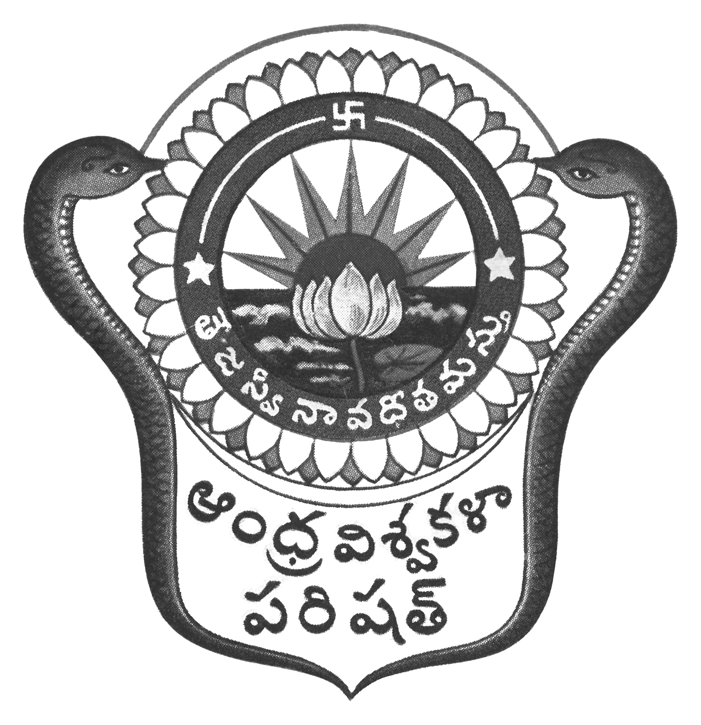
Prof.N.Vijay Mohan, M.P.Ed., DNIS., NIS., PG.DSM, Ph.D.  Director & Head  Dept. of Physical Education & Sports Sciences  Andhra University  Visakhapatnam-530 003 (AP) | 0891-2844496  Cell: 9703831117  vijaymohansports@gmail.com  ausportsvsp@gmail.com  Web: andhrauniversity.edu.in

To Date: 06-09-2018
The Principals,
Affiliated Colleges of Andhra University,

Sir/Madam,

The Andhra University Inter-Collegiate-cum-University Cross Country (Men & Women) team selections will be held at AU Golden Jubilee Grounds on 10-09-2018 at 5.00 AM (10 km for both Men & Women). The players may report at the venue with the necessary eligibility along with passport size photograph duly signed by the Principal (Facsimile not allowed) on the reverse side on the photograph and pinned to the eligibility Performa. Students born on or after 01-07-1993 are eligible. The players should report at 5.00 AM to the Organizing Secretary with eligibility.
Thanking you,
Yours sincerely,
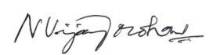
(N.VIJAY MOHAN)
Reporting Time: 5:00 AM on 10-09-2018

