ANDHRA UNIVERSITY
DEPARTMENT OF PHYSICAL EDUCATION AND SPORTS SCIENCES
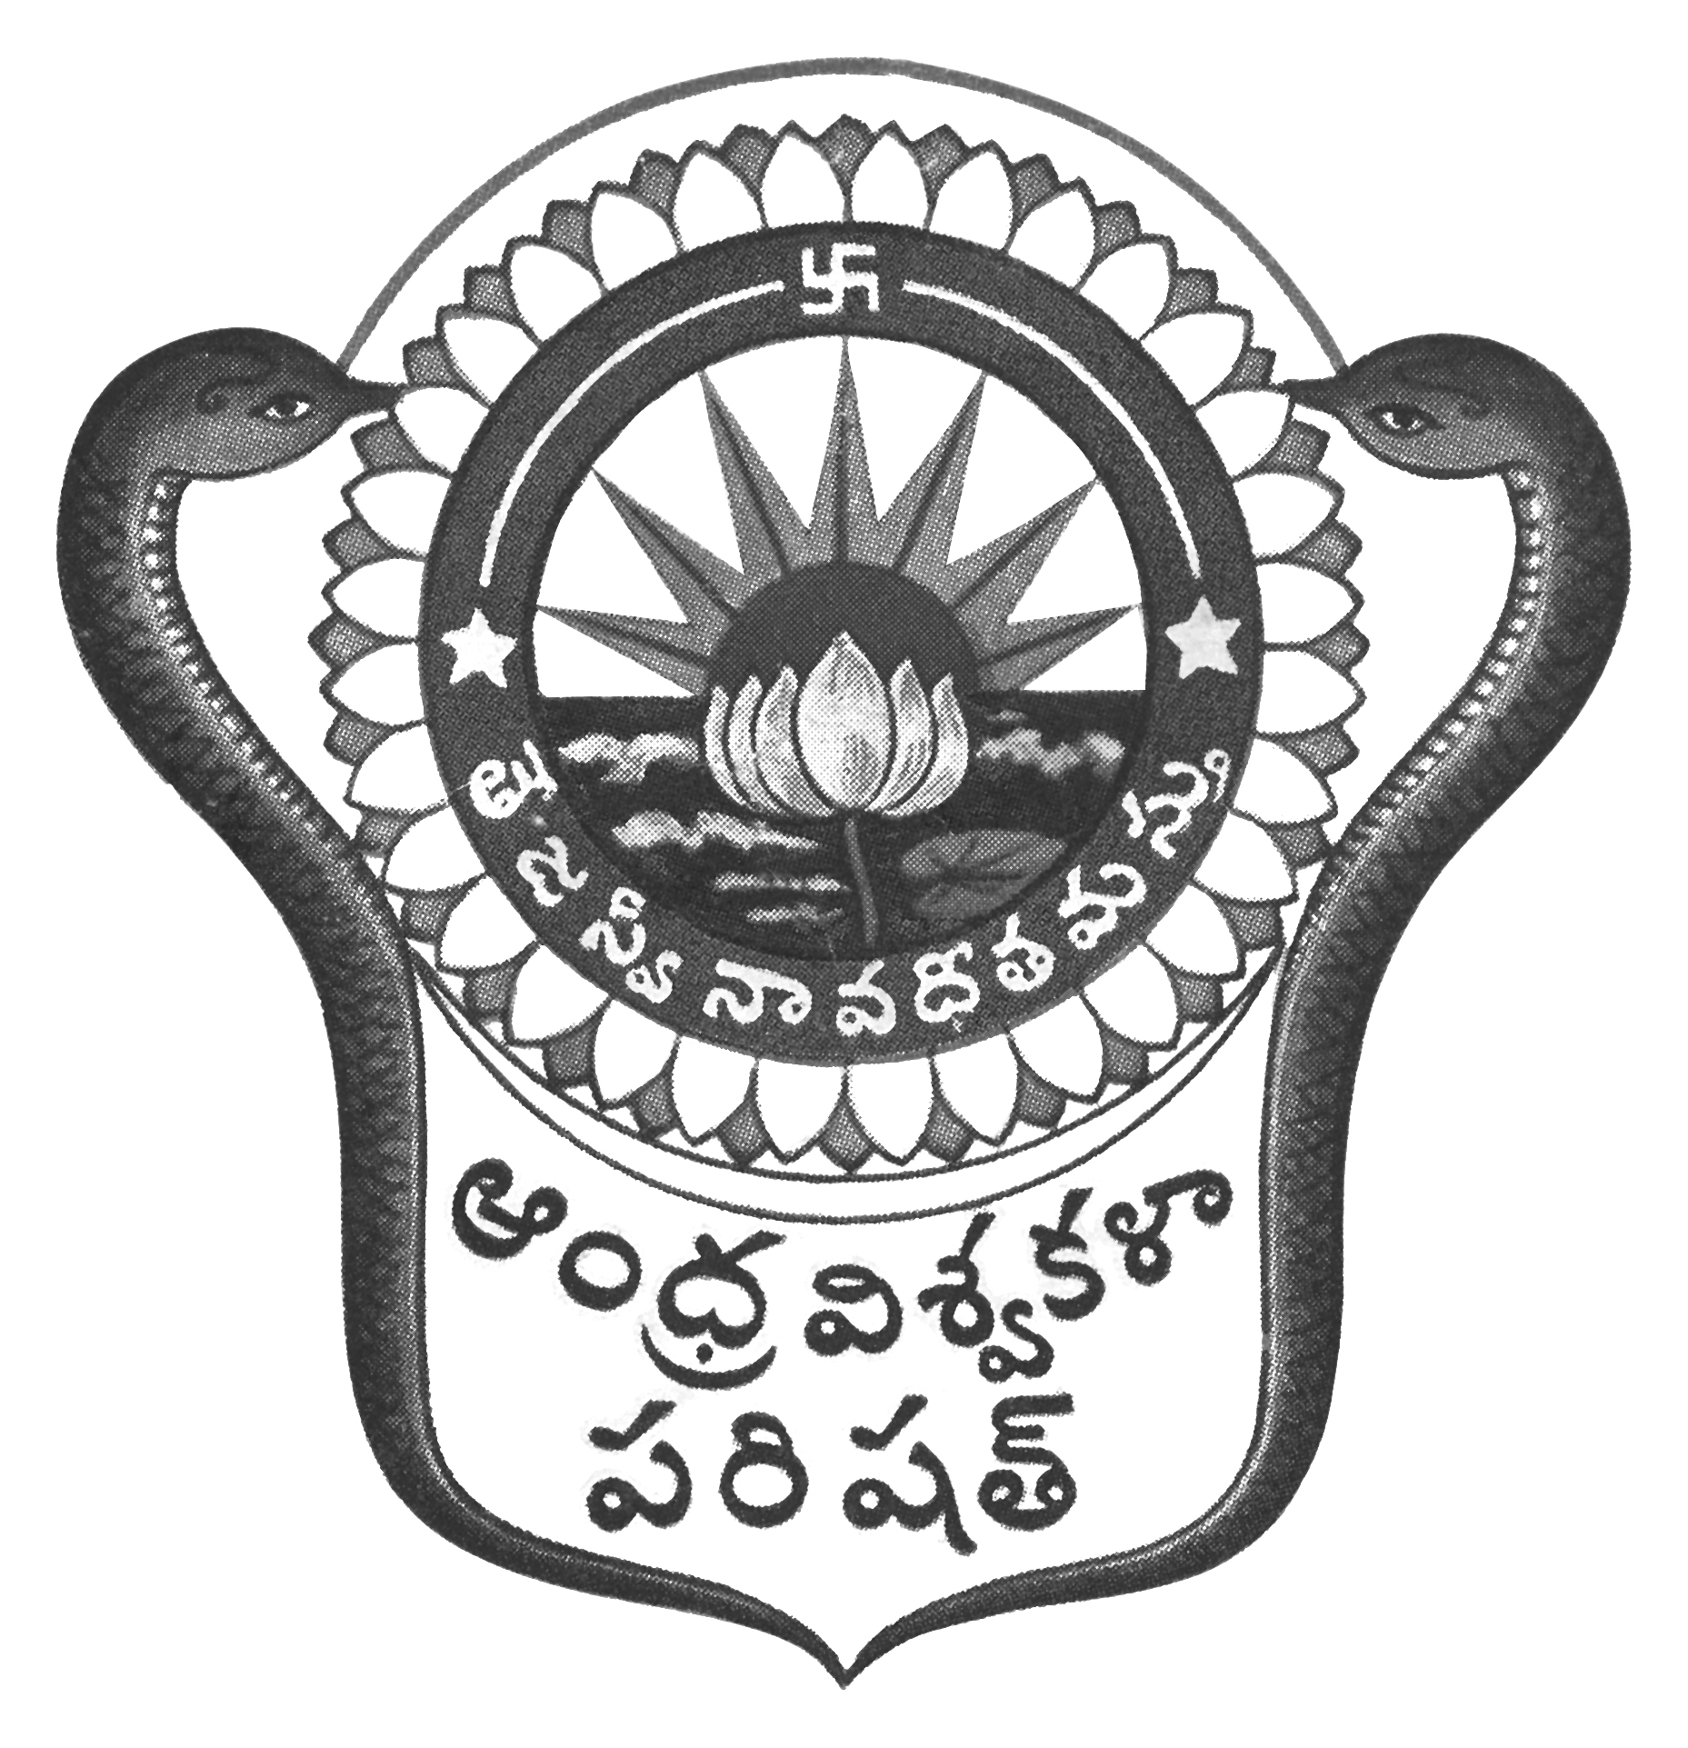
Prof.N.Vijay Mohan, M.P.Ed., DNIS., NIS., PG.DSM, Ph.D.  Director & Head  Dept. of Physical Education & Sports Sciences  Andhra University  Visakhapatnam-530 003 (AP) | 0891-2844496  Cell: 9703831117  vijaymohansports@gmail.com  ausportsvsp@gmail.com  Web: andhrauniversity.edu.in

To Date: 22-09-2018
The Principals,
Lecturers in Physical Education/Physical Directors
Affiliated Colleges of Andhra University

Sir/Madam,

Since the Municipal Aqua Swimming Pool, Beach Road, Visakhapatnam available, the Swimming Men & Women Andhra University Inter-University team selections will be held at Visakhapatnam only on 25.09.2018 students are required to report at 8.00 am at the venue.

VENUE: Aqua Swimming Pool, Beach Road, Visakhapatnam
Contact: 9985399955 & 7386588712

Thanking you,
Yours sincerely,
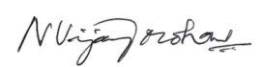
(N.VIJAY MOHAN)

