B.ARCHITETURE SYLLABUS
For admitted batches of 2015-16 onwards


DEPARTMENT OF ARCHITECTURE
ANDHRA UNIVERSITY COLLEGE OF ENGINEERING (A)
VISAKHAPATNAM
DEPARTMENT OF ARCHITECTURE, AU COLLEGE OF ENGINEERING

SCHEME OF INSTRUCTIONS & EVALUATION

FOR ADMITTED BATCHES 2015-16

1/5 B.ARCH 1ST SEMESTER
S.No | Code No. | Subject | Scheme of Instruction |  |  |  |  | Scheme of Examination
 |  |  | Credits | Lectures  (periods/  week) | Tutorials/  Drawing  (periods/  week) | Lab Hrs | Total  (periods/  week) | Internal | External | Total | Duration of exam
1 | 06.1.1.1 | Basic Design & Visual Arts | 8 | 2 | 6 | - | 8 | 50 | 50 | 100 | 5 Hrs.
2 | 06.1.1.2 | Architectural Drawing & Graphics-1 | 5 | 2 | 3 | - | 5 | 50 | 50 | 100 | 5 Hrs.
3 | 06.1.1.3 | Building Materials & Building Constructins-1 | 6 | 2 | 4 | - | 6 | 50 | 50 | 100 | 5 Hrs.
4 | 06.1.1.4 | Introduction to Architecture, Art Culture | 3 | 3 | 0 | - | 3 | 30 | 70 | 100 | 3Hrs.
5 | 06.1.1.5 | Structural Mechanics-1 | 4 | 4 | 0 | - | 4 | 30 | 70 | 100 | 3Hrs.
6 | 06.1.1.6 | English | 3 | 3 | 0 | - | 3 | 30 | 70 | 100 | 3Hrs.
7 | 06.1.1.7 | Survey & Site Studies | 3 | 2 | 0 | 3 | 5 | 50 | 50 | 100 | Practical
8 | 06.1.1.8 | Sports/NSS/NCC | 2 | 3 | 0 | - | 3 | - | - | -
 |  | Total | 34 | 21 | 13 | 3 | 37 | 290 | 410 | 700

1/5 B.ARCH 2nd SEMESTER
S.No | Code No. | Subject | Scheme of Instruction |  |  |  |  | Scheme of Examination
 |  |  | Credits | Lectures  (periods/  week) | Drawing  (periods/  week) | Lab  Hrs. | Total  (periods/  week) | Internal | External | Total | Duration of exam
1 | 06.1.2.1 | Architectural Design-I | 8 | 2 | 6 | - | 8 | 50 | 50 | 100 | 5 Hrs
2 | 06.1.2.2 | Architectural Drawing & Graphics-II | 5 | 2 | 3 | - | 5 | 50 | 50 | 100 | 5 Hrs
3 | 06.1.2.3 | Building Materials & Building Construction-II | 6 | 2 | 4 | - | 6 | 50 | 50 | 100 | 5 Hrs
4 | 06.1.2.5 | History of Architecture –I | 3 | 3 | 0 | - | 3 | 30 | 70 | 100 | 3 Hrs.
5 | 06.1.2.6 | Structural Mechanic-II | 4 | 4 | 0 | - | 4 | 30 | 70 | 100 | 3 Hrs.
6 | 06.1.2.7 | English Lab | 2 | 3 | 0 | - | 3 | 50 | 50 | 100 | 3 Hrs.
7 | 06.1.2.8 | Workshop Practice | 3 | 2 | 0 | 3 | 5 | 50 | 50 | 100 | Practical
8 | 06.1.2.9 | Sports/NCC/NSS | 2 | 3 | 0 | - | 3 | - | - | - | -
 |  |  | 33 | 21 | 13 | 3 | 37 | 310 | 390 | 700

1ST YEAR 1ST SEMESTER

06.1.1.1: BASIC DESIGN AND VISUAL ARTS:
Credits | 08 | Lab (Hrs.) | -
Lectures (Periods /week) | 02 | Internal Marks | 50
Tutorials/ drawing(periods/week) | 06 | External Marks | 50
 |  | Duration of Exam | 5.00Hrs.

Course Objective:
Basic Design provides the framework for understanding design as a new language by sensitizing students to the conceptual, visual and perceptual issues involved in the design process. The Course provides with knowledge of the principles of design and design elements. Exercises complement the lectures and ensure that the students learn to develop a series of compositions in two and three dimension.

Course Outcomes:
Exercises complement the lectures and ensure that the students learn to develop a series of compositions in two and three dimension.
The Course also prepares ground for the students to gain an understanding into the fundamental issues in architectural design and develop the skill to create architectural solutions for simple problems.

Course Contents:

Freehand drawing:

Introduction to fundamentals of drawings and its practice.
Free hand line sketching and drawing of natural and man-made.
Study of shades and shadows. Object drawing, simple, natural and geometric forms.
Outdoor Sketching of Historic or new built up structures of Architectural importance using different mediums.
Elements of Design:
Introduction to design: Meaning of design, importance of design.
Fundamental elements of design and their definitions-point, line, shape, form, space, texture, value and colour.
Principles of design:
Introduction to the principles of design - unity, balance, symmetry proportion, scale, hierarchy, rhythm, contrast, harmony, focus etc.
Ordering principles – axis, symmetry, hierarchy, Rhythm, Datum, and Transformations.
Colour:
Colour theory, colour wheel, primary, secondary, tertiary colours, colour schemes, colour value & intensity.

Principles of Perception:
Proximity, Similarity, Closure (Gestalt type). Optical illusion
Form and space:
Understanding properties of form, Articulation and Transformation of form – additive, subtractive and dimensional transformations.
Form defining space
Assignments:
Sketches,sheets and Models to understand basic design principles, elements and their expressive qualities.
Creative Exercises of 2d to 3d compositions.
Exercise related to positive and negative spaces
Mural, ideogram, 3D Abstract models

Text books:
1. Francis, D.K.Ching – Form Space & Order
References:
- Wong Wucius – Principles of two dimensional designs
- Ikuyoshi Shibikawa and Yumi Takahashi – Designer s Guide to Colour
3. Von Mesis – Elements of architecture
4. Robkrier – Architectural Composition
5. Johannes Itten – Design & Form
6. Donald E. Helper, Paul I. Wallach – Architecture Drafting & Design
7. David A.Hanks: The Decorative Design of Frank Lloyd Wright.
8. K.W.Smithies Principles of Design in Architecture.
9. Alan pipes – Drawing for 3 – dimensional design.

06.1.1.2: ARCHITECTURAL DRAWING & GRAPHICS –l

Credits | 05 | Lab (Hrs.) | -
Lectures (Periods /week) | 02 | Internal Marks | 50
Tutorials/ drawing(periods/week) | 03 | External Marks | 50
 |  | Duration of Exam | 5.00Hrs.

Course Objective:
The course introduces students to fundamental techniques of architectural drawing and develops the appropriate skills for representation.
Course Outcomes:
Students learn to develop drafting skills to to facilitate effective visual communication.
Course Content:
1. Introduction to Drawing:
Introduction to drawing equipment, familiarization, use and handling. Drawing sheet sizes, layouts and composition. Simple exercises in drafting, line types, line weights; dimensioning. Lettering Styles: Roman and Gothic style lettering; Freehand lettering, title panels and legends.

2. Simple Geometrical Construction:
Constructing simple and complex geometrical shapes involving various drafting technique drawing regular shapes; Special methods of drawing regular polygons; Regular polygons inscribed in a Circle.

3. Projections and section of Solids:
Solids of revolution, solids in simple position, Axis perpendicular to a plane, axis parallel to both planes, axis inclined to both planes etc
Section planes, true shape of section, Sections of Prisms, Pyramids, Cylinders, Cones, Spheres etc

4. Advanced geometry:
Intersection of surfaces
Line of intersection, intersection of prism and prism, cylinder and cylinder, cylinder and prism, cone and cylinder, cone and prism, cone and cone, sphere and cylinder or prism. Orthographic Projections-Representation of 3D elements in Plan and Elevations, Study of isometric, axonometric and oblique views, Ionic volute (by Gibbs Rule), Entasis of column, intersection of solids &

5. Architectural Symbols:
Representation of building elements, openings, materials, furniture and accessories; human postures; vegetation; vehicles; terminology and abbreviations used in architectural representation.

6. Measuring and Drawing to Scale:
Scales and construction of scales, scaled drawings of simple objects, furniture, rooms, doors and windows etc., in plan, elevation and section. Reduction and enlargement of drawings.

Text books:
l. N.D.Bhat, V.M.Panchal “Engineering Drawing” – Plane and Solid Geometry.
2. P.S.gill – A text book of Geometrical Drawing.
3. Francis D K Ching - Architectural Graphics.

References:
1.Moris.I.H. “Geometrical drawing for Art students”.
2.Nelson J.A. – Hand book of Architectural & Civil Drafting.
3.John D.Bies – Architectural Drafting: Structure & Environment.
4.Thoms. E. French – graphic Science & Design.
5.T.B.Nichols and Normal keep – Geometry of Construction.
6.Shah: Building Drawing.
7.Drawing architecture – Paul Hagarth
8.Drawings by architects – Claudius Conli
9.Pencil techniques in modern design – Alkin, Urbelleth and Lione
06.1.1.3: BUILDING MATERIALS & BUILDING CONSTRUCTION-I

Credits | 06 | Lab (Hrs.) | -
Lectures (Periods /week) | 02 | Internal Marks | 50
Tutorials/ drawing(periods/week) | 04 | External Marks | 50
 |  | Duration of Exam | 5.00Hrs.

- Elementary construction methods:
Explaining basic principles of Load bearing and Framed structures.

2. Mortars – Cement, sand, lime:
Sand: Sources of sand , classification, functions, properties, tests for silt and organic contents, size of sand and grading.

Mortar : Types, proportioning, mixing and grinding, mortar mills. Surkhi mortar, cement mortar, methods of preparing, handling and uses of mortars, light weight mortars i.e. cinder, sawdust and fibrous plasters, gypsum, plaster, composition and uses, Plaster of Paris.

3. Brickwork:
Claybricks:
. Constituents, harmful constituents, and selection of clay, requirements and tests. Fire clay bricks ;varieties; sand lime bricks; paving bricks; Terra-cotta-its varieties; ordinary, glazed, porous, polished and fine-uses and properties.

Various types of bonds, stopped ends, junctions, piers, jambs, footings,
foundations, corbelling, damp proof course, window sills, thresholds, copings, mortar joints and pointing.

4. Stone masonry:
Classification of stones:
Granite, laterite, quartzite, marble and slates –properties and uses; stones, paving sets. Preservation of stonework, quarrying of building stones, quarry dressing tool used.

Technical terms; stone walls, rubble work, ashlar work, masonry joints, window sills, plinth, cornices, surface finishes.

5. Lintels & Arches:
Lintels of wood, stone, brick, etc.
Arches:Terms defined; various forms of arches like segmental, semicircular, elliptical, three-centered, flat and relieving arch, etc.

06.1.1.4: INTRODUCTION TO ARCHITECTURE, ART & CULTURE

Credits | 03 | Lab (Hrs.) | -
Lectures (Periods /week) | 03 | Internal Marks | 30
Tutorials/ drawing(periods/week) | -- | External Marks | 70
 |  | Duration of Exam | 3.00Hrs.

Course Objective:
To analyze various art forms, and understand the techniques involved in creative thinking

Course Outcome:
The Course is intended to provide brief background knowledge of Culture and Art in different parts of the world.

Course Content:
Unit I: Introduction to Art, Culture, Society, Civilization and Architecture.
Unit II: Earlier attempts of man for shelter and shelter forms since the prehistoric period with reference to culture, climate, technology and material
Unit III: Understanding the relationships of art, culture and architecture at different time such as : art , arts & crafts movement etc , periods in the world history.
Unit IV: Indian Art and Architecture.
Unit V: Western Art and Architecture.
Unit VI: Elements of Art & Principles of Design studied from historic examples.
Unit VII: Study of ornament in Architectural Design, different types of ornamentation in buildings and study of historic examples
Unit VIII: Present day trends in visual arts and Architecture

Documentation
The study of any vernacular settlements and buildings of the region to understand construction methods, plans and building façade, organization in relation to aesthetic / religious/ social philosophy and environmental factors
Assignments: Sketches, notes, tutorials, tests and presentations

Reference: Story of Architecture.
Case studies:
The study of vernacular settlements and buildings of the region to understand construction methods, plans and building façade, organization in relation to aesthetic / religious/ social philosophy and environmental factors in the Visakhapatnam metropolitan region.

Text books:
References:
1.Craven, C. Roy. Indian Art a Concise History.
2. Christopher Alexander, Pattern Language, New York: Oxford University Press
3. Thomas Mitchell, Redefining Designing: From to Experience,
4. A history of architecture – Sir Banister Fletcher
5. Introduction to architecture – Stephen Gardner.
6. A chronology of western architecture – Doreen Yarwood
7. The great ages of architecture – Bodo Lichy
8. World architecture – an illustrated history – Trewin Copplistone and others

06.1.1.5: STRUCTURAL MECHANICS-I

Credits | 04 | Lab (Hrs.) | -
Lectures (Periods /week) | 04 | Internal Marks | 30
Tutorials/ drawing(periods/week) | -- | External Marks | 70
 |  | Duration of Exam | 3.00Hrs.

- Introduction: forces, composition, resolution, moments and couples; transformation of couple; resolution of force into force and couple.
- Concurrent and non-concurrent co-planar force systems, resultant and equilibrate analytical and graphical solutions.
- Equilibrium of bodies acted upon by concurrent and non-concurrent co-planar force systems, forces and members of trusses by method of joints and method of sections.
- Simple stresses and strains, elasticity, stress, strain, types of stresses, elastic limit, modulus of elasticity, composite sections. Stresses due to change in temperature.
- Elastic constants, linear strain, lateral strain, Poisson’s ratio, volumetric strain, relation between E, N (or G), and K.
- Torsion of shafts – introduction to the basic equation τ/j = f_{s}/R = Gθ/l
- Beams: Shear force and bending moment diagrams for simply supported, cantilever and overhanging beams for various loads. Relation between shear force and bending moment.
- Moment of inertia, Polar moment of inertia and section modulus for various structural shapes.

Text books:
- Mechanics of solids by S.S. Bhavikatti
- Engineering Mechanics by S.P.Timoshenko & D.H.Young
- Analysis of Structures - Analysis, Design and Details of Structures (Vol.1) by V.N.Vazirani and M.M.Ratwani

References:
      - Elements of strength of materials by Timoshenko & Young
      - Applied Mechanics by S.Ramamrutham.

06.1.1.6: ENGLISH

Credits | 03 | Lab (Hrs.) | -
Lectures (Periods /week) | 03 | Internal Marks | 30
Tutorials/ drawing(periods/week) | -- | External Marks | 70
 |  | Duration of Exam | 3.00Hrs.

Vocabulary: Word Search, Discuss and Note – Word Quiz – A List of 100 Basic Words – One Word Substitutes – 100 Difficult Words, Synonyms, Antonyms, Idioms, Technical Terms.

Grammar: Types of Sentences, Verbs, Adverbs, Pronouns, Adjectives, Gerunds & Infinitives, Articles, Quantifiers, Punctuations, Conjunctions, Exclamation.

Reading: Famous People – What is Personality, Personality based on Blood Groups – News Report, Magazine Article, Mobile Towers and Health – An Excerpt from Short Story, An Excerpt from a Biography – Open Letter to Prime Minister, Business Dilemmas: An Email Exchange – A Review of IPL: The Inside Story, Marck Zukerberg: World’s Youngest Billionaire – Solar Power: The Way Forward, From the Very Small to the Very Large.

Listening: Life in a Hostel – Eating Away those Blues!, Meeting Carl Jung – A Documentary on the Big Cat – A Consultant Interviewing Employees – A Conversation about a Business Idea – An Interview with a Woman Engineer.

Speaking: Your Favorite Holiday Destination – Describe Yourself – Why we need to save our Tiger – A Dialogue – Your First Interview – Pair Work: Setting up a New Business-Great Engineering Achievements.

Scenario: Sharing a Flat – Living in the Twenty First Century – Global Warming – Reality TV – Recession – The Sky-High Project.

Writing: Writing Sentences – Using your Dictionary – Paragraph Writing, Arguing a Case – Essay, Formal Letters, Emails, Reports and Presentations.

Life Skills and Core Skills: Self Awareness and Self Motivation – Communication, Adaptability – Motivation, Problem Solving – Personal Presentation Skills, Stress Management – Professionalism Ethics – Innovativeness and Creativity.

OBJECTIVES:
Reading Skills

- Addressing explicit and implicit meanings of a text on current topics.
- Understanding the context.
- Learning new words and phrases.
- Using words and phrases in different contexts.

Writing Skills

- Using the basic structure of a sentence.
- Applying relevant writing formats to create paragraphs, essays, letters, emails, reports and presentations.
- Retaining a logical flow while writing.
- Planning and executing an assignment creatively.

Interactive Skills

- Analyzing a topic of discussion and relating to it.
- Participating in discussions and influencing them.
- Communicating ideas effectively.
- Presenting ideas coherently within a stipulated time.

Life Skills and Core Skills

- Examining self-attributes and identifying areas that require improvement: self-diagnosis and self-motivation.
- Adapting to a given situation and developing a functional approach to finding solutions: adaptability and problem solving.
- Understanding the importance of helping others: community services and enthusiasm.

LEARNING OUTCOMES:

- The overall performance of the students will be enhanced after the course; they will be in a position to make presentations on topics of current interests – politics, famous personalities, science and technology, tourism, work and business environment, with increased public speaking skills.
- Students will be able to read, listen, speak and write effectively in both academic and non-academic environment.
- The students will be updated with certain real life situations, which they can handle when come face to face.

Prescribed Text Book: Life Through Language: A Holistic Approach to Language Learning. Board of Editors, Pearson Publishers, India 2013.

Life Through Language: An Effective Learning Experience

Life through Language has a systematic structure that builds up communicative ability progressively through the chapters. It will enable the learner to manage confusion; frame question for themselves and others; develop new ideas; support ideas with evidence; express themselves with poise and clarity; and think critically. Acquisition of skills leads to confidence.

Chapter – 1

People and Places:- Word Search – Ask Yourself – Self-Assessment-I – Self-Assessment – II - Sentence and its types – A Guide book entry – Life in a Hostel-Your Favorite Holiday Destination – Designing a Holiday- Writing Sentences – Self-Awareness – Self-Motivation.

Chapter – 2
Personality and LifeStyle:- Word Quiz – Verbs – Adverbs – A Big Fat Wedding – Wine and Dine – Going Places – Negotiations – Proving Yourself – Meeting Carl Jung – Describing Yourself – Living in the 21st Century – Using Your Dictionary – Communication – Adaptability.

Chapter – 3

Media and Environment:- A list of 100 basic words – Nouns – Pronouns – Adjectives – News Report – Magazine Article – User’s Manual for new iPod – A documentary on the big cat – Why we need to save our tigers: A dialogue – Global warming – Paragraph Writing – Arguing a case – Motivation – Problem Solving.

Chapter – 4

Entertainment and Employment:- One word substitutes – Parts of Speech – Gerunds and infinitives-An excerpt from short story-An excerpt from a biography-A Consultant interviewing employees-Your first Interview-Reality TV-Writing an essay-Correcting Sentences-Integrity Sense of humor.

Chapter – 5

Work and Business:- A list of 100 difficult words – Articles, Quantifiers – Punctuation – Open Letter to Prime Minister Business Dilemmas: An email exchange – A review of IPL: The Inside Story, Mark Zuckerberg: World’s Youngest Billionaire-A Conversation about a business Idea-Pair Work: Setting up a new business-Recession-Formal Letters-Emails-Reports-Professionalism-Ethics.

Reference Books:

- Basic Vocabulary. Edgar Thorpe, Showick Thorpe. Pearson P. 2008
- Quick Solutions to Common Errors in English, Angela Bunt. MacMillan P. 2008
- Know Your English (Volume 1 & 2), by Dr. S. Upendra, Universities Press, India 2012
- Business Communication Strategies. Maathukutty Monipally. Tata Mc Grahill P. 2009.
06.1.1.7 SURVEYING & SITE STUDIES

Credits | 03 | Lab (Hrs.) | 03
Lectures (Periods /week) | 02 | Internal Marks | 50
Tutorials/ drawing(periods/week) | -- | External Marks | 50
 |  | Duration of Exam | Practical

Basic principles and chain surveying:
Definitions, scales and symbols, sources of error in surveying and theory of probability, measurement of distance, instruments used, ranging of survey lines, chaining a line with examples, chaining on sloping ground, errors in chaining, tape corrections, chain surveying principles, off-sets, field notes, instruments, obstacles in chaining, plotting chain survey with practical examples.
Traversing and plain table surveying:
Tape and chain traversing, instruments used, methods of traversing, bearing lines, local attraction, plotting, magnetic declination, precautions in using compass, traversing by theodolite, instruments used and methods, plain table surveying methods, two point and three point problems, exercise in preparation of base map of small areas.
Computation of areas and leveling
Computation of areas, from field notes and from plan with examples, leveling:
instruments used, definitions principles, reduction of levels classification of leveling, errors in leveling contouring; characteristics of contour lines, interpolation and interpretation of contours, uses of contour lines.

Automated surveying:
introduction to the use of digital surveying technologies such as total station, G.P.S through demonstrations.
Site studies:
Plot, site, land and regions, size, shape of sites. Analysis of accessibility, topography, climate, landforms, surface drainage, soil, water, vegetation, ecology and visual
aspects.
Note: Field book to be submitted at the end of the semester.
Viva Voce:
Student should field book and they should attend a practical Exam and Viva voce conducted by both an external and an internal examiner.

Text books:
- Surveying vol-I – B.C.Punmia
- Text book of Surveying – C. Venkataramiah, Unversiities Press.
References:
1. Planning design criteria- joseph de chiara & lee coppleman
2. Site planning – Kevin Lynch
1ST YEAR 2ND SEMESTER

06.1.2.1:ARCHITECTURAL DESIGN-I

Credits | 08 | Lab (Hrs.) | --
Lectures (Periods /week) | 02 | Internal Marks | 50
Tutorials/ drawing(periods/week) | 06 | External Marks | 50
 |  | Duration of Exam | 5:00 Hrs.

Course objectives:
Lectures on theory of Architecture and principles of planning. Elements of composition, analytical classification of spaces for different uses and their relation to one another. Study of horizontal and vertical circulation in buildings. detailed study of analysis of sites and surroundings
Course Outcomes:
To understand principles of design. To develop the ability to translate abstract
principles of design into architectural solutions for small problems.

Course Content:

Organisation of form and space
Spatial relationship and spatial organisation
Circulation
Path space relationship, elements and form of circulation
Proportion and scale
golden section, classical orders, modular, anthropometry, Understanding of human and visual scale. An understanding of basic human functions and their implications for space requirements. Minimum and optimum areas for various functions, User data-Bubble and circulation diagrams

Assignments:

The list of suggested topics to be covered as design problems including preparation of measured drawings and design of single unit spaces with emphasis on form

•Detailed study of spaces such as living, dining, bedrooms, kitchen, toilet, etc. including the furniture layout, circulation, clearances, lighting and ventilation, etc.
Application in the design of simple household and street furniture At least two design problems Examples such as Design of Bus shelter/ Milk booth, /Security cabin/ATM center/ Internet center/ Gateway
References:
1.Time Savers Standards.
2. Architect’s Data- Ernst Neufert
3.Architect’s handbook- Charanjit Shah.
4. Form Space & order – Frantis, K. Chary

06.1.2.2: ARCHITECTURAL DRAWING & GRAPHICS –II

Credits | 05 | Lab (Hrs.) | --
Lectures (Periods /week) | 02 | Internal Marks | 50
Tutorials/ drawing(periods/week) | 03 | External Marks | 50
 |  | Duration of Exam | 5:00 Hrs.

Course Objective:
The course introduces students to fundamental techniques of architectural drawing and develops the appropriate skills for visualization and representation .

Course Outcomes:
Students learn to develop drafting skills to to facilitate effective visual communication.

Course Content:

1. Perspective:
Introduction to Perspective in one point or parallel perspective, two point or angular perspective, introduction to three-point perspective of different geometrical form, built forms.

2. Sciography:
Introduction to Sciography in the study of shade and shadows, points, lines, surfaces, geometrical solids of various forms and groups of forms leading to advanced examples of shades and shadows on buildings or parts of buildings.

3. Rendering:
Introduction to the rules of composition and perspective in architectural rendering, color study, values, tones and general approach to rendering. Various colour schemes, water colour and poster colour rendering, pencil rendering and monochrome and wash rendering etc. treatment of sky, clouds, landscape elements, human figures, foreground and surroundings, shadow projections in renderings

Assignment
- Sketching-incorporating above principles
- Architectural Documentation:
Detailed measured drawing and documentation of any interesting building – preparation of maps, plans, elevations, sections, views etc.

Text books:
l. N.D.Bhat, V.M.Panchal “Engineering Drawing” – Plane and Solid Geometry.
2. Francis D K Ching - Architectural Graphics.

References:
1.Perspective – space and design – Lance Bowen Bellings.
2.Moris.I.H. “Geometrical drawing for Art students”.
3.Nelson J.A. – Hand book of Architectural & Civil Drafting.
4.P.S.gill – A text book of Geometrical Drawing.
5.John D.Bies – Architectural Drafting: Structure & Environment.
6.Thoms. E. French – graphic Science & Design.
7.T.B.Nichols and Normal keep – Geometry of Construction.
8.Shah: Building Drawing.
9.Drawing architecture – Paul Hagarth
10.Drawings by architects – Claudius Conli
11.Perspective – H. Pranchlay
12.Pencil techniques in modern design – Alkin, Urbelleth and Lione
13.Perspective – space and design – Lance Bowen Bellings.

06.1.2.3: BUILDING MATERIALS & BUILDING CONSTRUCTION-II

Credits | 06 | Lab (Hrs.) | --
Lectures (Periods /week) | 02 | Internal Marks | 50
Tutorials/ drawing(periods/week) | 04 | External Marks | 50
 |  | Duration of Exam | 5:00 Hrs.

1. Timber:
Timber Advantages of timber construction, exogenous and endogenous trees, hard wood and and soft wood, growth of tree and its structure: wood and heart, felling of trees, conversion of felled logs, storage, sawing of timber, shrinkage and distortion, wastage, method of sawing. Drying and seasoning, moisture contents, purpose of seasoning, natural artificial.

Defects in timber: Natural defects, seasoning defects and defects due to fungal action. Causes of decay, factors affecting decay, preservation of timber by applying preservatives like tar, oil, water soluble and organic solvents.

2. Veneers and veneering:
Resin bonded plywood, laminated wood, insulating boards and other miscellaneous Boards. Varieties of Timber, Characteristics and Uses

3. Carpentry and joinery:
Terms defined, mitring, ploughing, grooving, rebating, veneering, various forms of joints in wood work, such as lengthening joints, bearing joints, halving, dovetailing, housing, notching, tusk and tenon, etc.

4. Doors:
Definition of terms, types of doors: wooden, ledged, ledged and braced, paneled, flush doors. Hinged, single and double shutters, sliding folding, revolving, pivoted.

5. Windows:
Ordinary casement, top and bottom hung, pivoted and sliding sash.
Hardware: fixtures, locks, hinges, fastenings, etc.

6. Wooden ground and upper floors:
Terms defined, bridging, joists, binder beams and
girders, solid and herringbone strutting, floor boards, ceiling joists, trimming floors to accommodate fire place.

06.1.2.4. HISTORY OF ARCHITECTURE-I

Credits | 03 | Lab (Hrs.) | --
Lectures (Periods /week) | 03 | Internal Marks | 30
Tutorials/ drawing(periods/week) | -- | External Marks | 70
 |  | Duration of Exam | 3:00 Hrs.

Course Objectives:
History of architecture to be studied as history of development of building forms (3D) ornamentation, structural solutions, construction methods, plans and building façade, organization in relation to aesthetic / religious/social philosophy and environmental factors. The study should focus on the general trends and not on specific examples/ buildings.

Course Outcome:
1) Acquire knowledge to identify the common characteristics among the
monuments of a particular style.
2) Acquire graphic skills to present a building, analyze its elements and explain
the composition.
3) Acquire knowledge on good practices of architecture in the past.

Course content:
• Architectural development in the ancient civilizations in Egypt and Mesopotamia, study of pyramids, temples, mastabas, ziggurats, etc.
• Architecture in the classic Greek and roman periods, temples, agoras gateways, circuses, amphitheatres, basilicas, etc.
• Architecture in the early Christian, Romanesque gothic, Byzantine, periods in Europe and rest of the world excluding Asia.
Internal evaluation will be through tests and/ or a seminar to be presented by each student using maps, plans, section/ elevations/ views and other diagrammatic and graphic means.
Text Books:
1. A history of architecture – Sir Banister Fletcher
References:
1. World architecture – an illustrated history – Trewin Copplistone and others
2. Introduction to architecture – Stephen Gardner.
3. A chronology of western architecture – Doreen Yarwood
4. The great ages of architecture – Bodo Lichy
5. Meaning in western architecture – Christian Noberg Schulz

06.1.2.5. STRUCTURAL MECHANICS-II

Credits | 04 | Lab (Hrs.) | --
Lectures (Periods /week) | 04 | Internal Marks | 30
Tutorials/ drawing(periods/week) | -- | External Marks | 70
 |  | Duration of Exam | 3:00 Hrs.

- Theory of simple bending; M/I=f/y=E/R, application of flexural formula.
- Bending and Shearing stresses distribution in beams for different sections.
- Combined stresses (direct and bending stresses) of symmetrical and unsymmetrical sections-beams
- Deflection of beams: Relation between slope, deflection and curvature, Deflection of cantilever and simply supported with different loadings using double integration method and moment area methods.
- Propped cantilever beams: Shear Force and Bending Moment diagrams.
- Analysis of beams and frames: BM& SF diagrams for Fixed and Continuous beams. Application of Clapeyron’s theorem of three moments, Moment distribution method for continuous beams. Kani’s method of analysis for structural frames including sway.
- Three Hinged Arches- determination of horizontal thrust, radial shear, normal force, and axial thrust. Shear force and bending moment diagrams for three-hinged arch.
Text books:
- Analysis of Structures - Analysis, Design and Details of Structures (Vol.1 and Vol.2) by V.N.Vazirani and M.M.Ratwani
- Basic structural analysis by C.S. Reddy

References:
- Intermediate Structural analysis by C.K.Wang
- Elements of strength of materials by Timoshenko & Young
- Structural mechanics – Punmia

06.1.2.6: ENGLISH LAB

Credits | 02 | Lab (Hrs.) | --
Lectures (Periods /week) | 03 | Internal Marks | 50
Tutorials/ drawing(periods/week) | -- | External Marks | 50
 |  | Duration of Exam | 3:00 Hrs.

The Language Lab focuses on the production and practice of sounds of language and
familiarizes the students with the use of English in everyday situations and contexts.
SYLLABUS:
1) English Sound Pattern-Letters
2) Sounds of English
3) Pronunciation
4) Stress and Intonation

OBJECTIVES:

- To make students recognize the sounds of English through Audio-Visual aids.
- To help students build their confidence and help overcome their inhibitions and selfconsciousness while speaking in English. The focus shall be on fluency.
- To familiarize the students with stress and intonation and enable them to speak English effectively.

LEARNING OUTCOMES:

- Students will be sensitized towards recognition of English sound pattern.
- The fluency in speech will be enhanced.

Prescribed Text Book: Speak Well, Board of Editors, Orient Black Swan Publishers,
Hyderabad, 2012.

Speak well, the print as well as audio materials, is learner friendly and suitable for use in a multimedia language laboratory. These materials are developed to facilitate practice in improving the intelligibility and communication skills in English, for technical, students at the undergraduate level.

The materials mainly aim at self-study, monitory by a teacher whenever essential. The
teacher intervention is kept to a minimum, only to give right direction to the learners.

Communication in any language depends on clarity of speech. This is true of English too. Articulation of the sounds, and pronunciation of words from the basis for intelligibility. The few units focus on bringing home the importance of this aspect with copious examples and opportunities for practice. Models of standard pronunciation are given. Explanations are kept short and simple. The IPA symbols, presenting the sound system in English, used in this book are the same as in Standard English dictionaries. These symbols are to be used at the recognition level to facilitate the learners’ use of the dictionary for pronunciation. Problem areas are pointed out and, where necessary, deviation in the pronunciation of Indian speakers of English are brought to the notice of the learners.

The units called ‘Interactions’ pay attention to natural conversational skills in different
contexts with focus on various functions of the language. Model conversations are provided as samples. Notes on appropriate expressions used in different situations drawn the learners’ attention to the use of language in context. Exercises and activities reinforce the functions introduced.

Unit-1: Letters and Sounds
Worksheet-1
Unit-2: Interactions-1
Worksheet-2
Unit-3: The sounds of English
Worksheet-3
Unit-4: Interactions-2
Worksheet-4
Unit-5: Pronouncing words- some important patterns
Worksheet-5
Unit-6: Interactions-3
Worksheet-2
Unit-7: Stress and Intonation
Worksheet-2

Reference books:
1. Cambridge English Pronouncing Dictionary, Cambridge University Press, India, 2012.
2. A Textbook of English Phonetics for Indian Students by T. Balasubramanian, Macmillan Publisher, 1981.

DISTRIBUTION AND WEIGHTAGE OF MARKS
- The practical examinations for the English Language Lab shall be conducted as per the University norms prescribed for the core Engineering practical sessions.

- For the Language lab sessions, there shall be a continuous evaluation during the semester for 50 Sessional marks and 50 semester-end Examination marks.

- For the 50 Sessional marks, 20 marks shall be awarded for day-to-day performance, 10 marks to be awarded by conducting Internal Lab Test(s), and 20 marks for work sheets attached to the lab manual.
- For the 50 semester- end (External) marks, 30marks shall be awarded for written examination (dialogues, the sounds of English and stress) and 20 marks for external examiner viva-voce, tested by way of reading a passage or a conversation.

Note: The external lab shall be conducted by the teacher concerned with the help of another English faculty of affiliated Colleges of the University/other Institutions.

06.1.2.7: WORK SHOP PRACTICE

Credits | 03 | Lab (Hrs.) | 03
Lectures (Periods /week) | 02 | Internal Marks | 50
Tutorials/ drawing(periods/week) | -- | External Marks | 50
 |  | Duration of Exam | Practical

Course content:
Model making: Preparation of wooden base for model Making of three dimensional building blocks & forms using different types of materials such as paper, rubber, acrylic, polystyrene, FRP, etc. Three to four exercises to be done.
Course outcome:
The course provides the foundation and capability to represent the concepts three dimensionally.

References:
- Designing with models – Criss. B. Mills.

I/V B.Arch. DEGREE EXAMINATION
Architecture
First Semester

BASIC DESIGN AND VISUAL ARTS

(Effective from the admitted batch OF 2015-2016)

(MODEL QUESTION PAPER)

Time: 5 Hours Max. Marks: 50

Part –A is compulsory.

PART – A 1x30m
- Design a logo for a yoga village in your city reflecting the purpose of the space, keeping in mind the design principles.

PART – B 2x10m
Answer any two
- With the help of neat sketches explain the following:
- Hierarchy b) Rhythm c) Datum.

- What are the elements of design? Elaborate with the help of diagrams.

- What is transformation? With the help of sketches describe various ways of transformation of forms.

- Distinguish between
- Analogous colours & contrasting colours.
- Tone & texture
- Warm colours and cool colours
I/V B.Arch. DEGREE EXAMINATION
First Semester

ARCHITECTURAL DRAWING AND GRAPHIC-I

(Effective from the admitted batch OF 2015-2016)

(MODEL QUESTION PAPER)

Time: 5 Hours Max. Marks: 50

Answer any five questions
All question carry equal marks

- Compose the profile of an Architects firm in A4 Size sheet.
- Construct a complex geometric pattern using any two geometricalshapes.
- Draw the projections of hexagonal pyramid base 30mm side and axis 60mm long having its base on the H.P and one of the edge of the base inclined at 45 degrees to the V.P
- Answer any two of the following
  - Write architectural style of lettering of the following in 2X2 cm “ARCHITECTURE IS THE MOTHER OF ALL ARTS”
  - Inscribe a regular pentagon in circle of dia 8cm.
  - Describe the importance of line types and weights
- Draw an Isometric view for Figure 1.
- Draw a 6M X 4M Living Room plan in 1:50 showing furniture, architectural symbols (like door window etc.) and also clearances as per standards.
- Draw an intersection of two cylinders of 15CM long and 5CM diameter, intersecting perpendicularly at theirrespective centres
- Answer any two of the following
  - Draw an involute of a square 4 cm x 4 cm.
  - Write at least 5 abbreviations used in architectural representation
  - Show graphical representation for glass, wood, stone, concrete, RCC
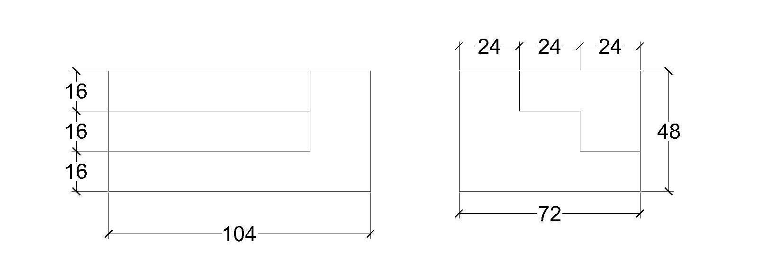
Figure 1
I/V B.Arch. DEGREE EXAMINATION
First Semester

BUILDING MATERIALS AND BUILDING CONSTRUCTION -1

(Effective from the admitted batch OF 2015-2016)

( MODEL QUESTION PAPER )

Time: 5 Hours Max. Marks: 50

Answer any one question in PART-1 (20 Marks)
Answer any THREE questions form PART-2 (30 Marks. Each 10 Marks)

PART – 1
- Draw to scale plans and elevations of alternative courses of 1 and 1½ brick thick wall in (a) English bond (b) Flemish bond. (adopt scale of 1:20)

- Draw a three centered arch with an opening size of 1.5M wide and 2.10 M height (from floor finishing to the key stone) and also mention all the technical terms of an arch. (adopt scale of 1:10)

PART – 2
- Explain basic principles of load bearing and framed structures. (10M)

- Write short notes on (5*2 = 10M)
- Bulking of sand
- Light weight mortars

- Give classification , qualities , uses and localities where they are available in India of the following stones (2*5 = 10M)
- Granite
- Limestone
- Marble
- Quartzite
- Sandstone

- What are the qualities of ideal preservatives? Mention the preservatives which are commonly used. (10M)

- Define the following with the help of neat sketches (5*2 = 10M)
- Steel lintels and R.C.C. lintels
- Lintel and arch
I/V B.Arch. DEGREE EXAMINATION
First Semester

INTRODUCTION TO ARCHITECTURE, ART, CULTURE

(Effective from the admitted batch OF 2015-2016)

(MODEL QUESTION PAPER)

Time: 3 Hours Max. Marks: 70

Answer any five questions.
All carry equal marks.

- Explain briefly about development of Ancient Civilizations.

- Write short notes on development of shelter forms from prehistoric period.

- Explain Arts and Crafts Movement.

- Explain about the elements and principles of design.

- What is ornament? Discuss about types of ornamentation in buildings.

- Write short notes on stages of early History of Architecture with suitable examples and sketches.

- Discuss the evolution of Architecture from the Renaissance to the contemporary.

- Write about present day trends in visual arts and Architecture.

I/V B.Arch. Degree Examination
First year, First Semester

STRUCTURAL MECHANICS-I

(With Effective from the admitted batch of 2015-16)
MODEL QUESTION PAPER
TIME: 3 HOURS Max. Marks: 70
Answer any FIVE Questions
All questions carry Equal Marks

- A man raises a 10-kg joist, of length 4 m, by pulling on a rope. Find the tension T in the rope and the reaction at A.(Refer Fig.1)

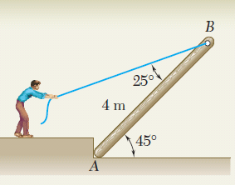
Fig.1
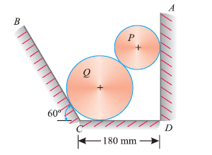
Fig.2

- Two cylinders rest in a channel as shown in Fig. 2. The cylinder P has diameter of 100mm and weighs 200N, whereas the cylinder Q has diameter of 180mm and weighs 500N. If the bottom of the box is 180mm with one side vertical and other inclined at 60°.Determine the reaction at all the four point of contacts.

- Using the method of joints, determine the force in each member of the truss shown in Fig. 3. Indicate whether the members are in tension or compression.

Fig.3
Fig.4

- Two smooth circular cylinders, each of weight W = 445N and radius r = 152mm, are connected at their centres by a string AB of length l = 406mm and rest upon a horizontal plane, supporting above them a third cylinder of weight Q = 890N and radius r = 152mm (Fig.4). Find the force S in the string and the pressure produced on the floor at the points of contact D and E.

- Determine the moments of inertia I_{x} and I_{y} of the shaded area with respect to side AB for the plane area shown in Fig.5.

Fig.5

Fig.6

- Draw the shear and bending-moment diagrams for the beam and loading shown in Fig. 6.
- Derive the basic equation τ/j = f_{s}/R = Gθ/l
- A specimen of steel 20 mm diameter with a gauge length of 200 mm is tested to destruction. It has an extension of 0.25 mm under a load of 80 kN and the load at elastic limit is 102 kN. The maximum load is 130 kN. The total extension at fracture is 56 mm and diameter at neck is 15 mm.
Find (i) The stress at elastic limit.
(ii) Young’s modulus.
(iii) Percentage elongation.
(iv) Percentage reduction in area.
(v) Ultimate tensile stress

I/V B.Arch. DEGREE EXAMINATION
Second Semester

ARCHITECTURAL DESIGN – I

(Effective from the admitted batch OF 2015-2016)

(MODEL QUESTION PAPER)

Time: 5 Hours Max. Marks: 50

Part –A is compulsory.

PART – A 1x40m
- Design an internet center for 6 cubicles and 1 reception / billing counter. The space should cater all the basic needs of the center like space for printers, waiting lounge, etc. The proposed site is 8m x 8m, with a 40’ wide approach road on north side.

Drawings to be submitted:
- Plan (including site) - 1:50
- Elevation – 2 nos - 1:50
- Section – 2 nos - 1:50
- Perspective

PART – B 1x10m
Answer any one
- Define scale. Distinguish between monumental scale and human scale with the help of suitable examples.

- Discuss the anthropometric data and clearances for
- Work station for an office.
- Kitchen counter
I/V B.Arch. DEGREE EXAMINATION
Second Semester

ARCHITECTURAL DRAWING AND GRAPHICS –II

(Effective from the admitted batch OF 2015-2016)

(MODEL QUESTION PAPER)

Time: 5 Hours Max. Marks: 50

PART-1is compulsory (20 Marks)
Answer any THREE questions form PART-2 (All questions carry equal marks)

PART – 1
- Draw the following
  - One-point perspective for Figure 1A with eye level at 1.5 M
  - Two-point perspective for Figure 2with eye level at 1.5 M
  - Three-point for Figure 1C with eye level at 4.0M
PART – 2
- Show the Sciography in plan and elevation for any two objects shown in Figure1
- Design an art wall at the entrance lobby of a nursery school conveying a theme
- Answer the following
  - Differentiate Shade and Shadow with suitable sketches
  - Define station point
  - Explain with neat sketches the symbols for any 5 hard and soft landscapes
- Draw a freehand perspective of Figure 2 and render with sky, tree and human to understand scale and proportion
- Draw a village settingduring festive season and render it with colour of any medium

Figure-1
Figure-2
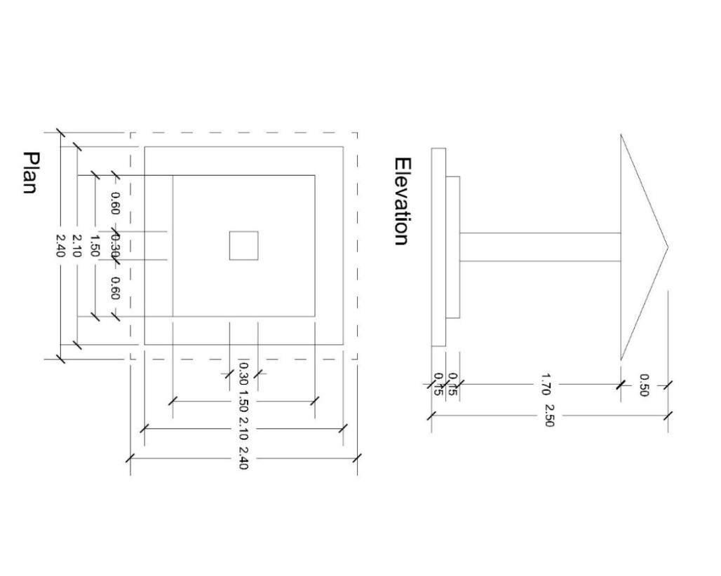
I/V B.Arch. DEGREE EXAMINATION
Second Semester

BUILDING MATERIALS AND BUILDING CONSTRUCTION -1

(Effective from the admitted batch OF 2015-2016)

(MODEL QUESTION PAPER)

Time: 5 Hours Max. Marks: 50

Answer any one question in PART-1 (20 Marks)
Answer any THREE questions form PART-2 (30 Marks)

PART – 1
- Draw a partly panelled and partly glazed door in an opening size of 1.20M X 2.10M in a 0.23M thick brick wall. Draw its plan, elevation and section to a scale of 1:20.

- Draw neatly double joist timber floor of span 4.00M X 6.50M. Draw its plan and sections showing details and methods of fixing bridging joist to binders. Also mention merits and demerits. (Adopt a suitable scale where details are all clear and legible in the drawing.)
PART – 2
- What is seasoning of timber? Why it is required? State various methods of seasoning and explain any one. (10M)

- Write short notes on (5*2 = 10M)
- Defects in timber
- Preservation of timber

- Explain the following types of joints with neat sketches (2*5 = 10M)
- Cogged joint
- Chase mortise joint
- Dovetail joint
- Tenon and mortise joint
- Fished joint

- Explain how plywood and laminated wood is manufactured. Mention their advantage. (10M)

- Write notes on the following and explain various types of hardware fixtures used for doors and windows with neat sketches(5*2 = 10M)
- Bay window
- Revolving door
I/V B.Arch. DEGREE EXAMINATION
Second Semester

HISTORY OF ARCHITECTURE – I

(Effective from the admitted batch OF 2015-2016)

(MODEL QUESTION PAPER)

Time: 3 Hours Max. Marks: 70

Answer any five questions.
All carry equal marks.

- Explain briefly about Mesopotamian Architecture.
- Describe briefly the features of Egyptian temples. Explain one of the examples with suitable sketches in detail.
- Discuss about ‘Mastaba’ and types of Mastabas with detail sketches.
- Explain different classic Greek orders with detailed sketches.
- a) Write short notes on temples at Rome with neat sketches.
b) Write short notes on coliseum at Rome.
6. Explain characteristic features of Romanesque with typical example.
7. With the help of neat sketches explain the features of Byzantine Architecture.
8. Discuss atleast two structures, built on ‘Acropolis’, Greek Architecture along with
details and sketches.

I/V B.Arch. Degree Examination
Second Semester

STRUCTURAL MECHANICS-II

(With Effective from the admitted batch of 2015-16)

MODEL QUESTION PAPER
TIME: 3 HOURS Max. Marks: 70
Answer any FIVE Questions
All questions carry Equal Marks

- Analyse the continuous beam shown in Fig.1 using the theorem of three moments. E is constant. Draw the shear force and bending moment diagrams.
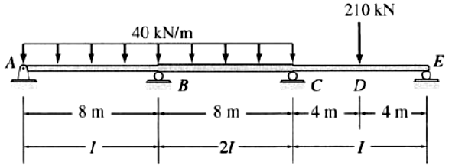
Fig.1
- Analyse the continuous beam shown in Fig.2 using moment distibution method. EI is constant. Draw the shear force and bending moment diagrams.
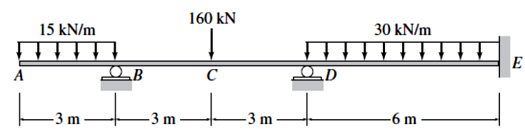
Fig.2
- Draw the bending moment diagram of a three-pinned circular arch shown in Fig.3.Also determine the horizontal thrust and radial shear at a distance of 5m from the left-hand support.
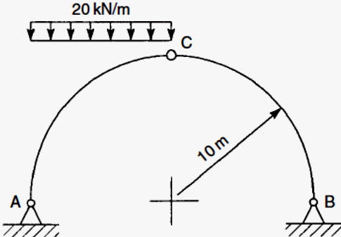
Fig.3
- Find the deflection at centre and slopes at the supports for a simply supported beam of span 4m with uniformly distributed load of intensity 6kN/m using moment-area method.
- Draw the shear force and bending moment diagram for a propped cantilever beam of span 6m with two point load 4kN and 6kN acting at a distance of 2m and 4m from fixed end.
- State the assumption in the theory of simple bending and derive M/I=f/y=E/R
- Draw the shear stress distribution for a symmetrical I-section with thickness of the web as 12mm, thickness of the flange as 12mm, overall depth of the section as 350mm and width of the flange as 200mm if the beam is subjected to a shear force of 20kN.
- An unsymmetrical I-section beam is used to support an imposed load of 2kN/m over a span of 8m. The beam is additionally subjected to a compressive force P of 100kN located at 50mm from the soffit of the beam (Fig.1). Determine the extreme fibre stresses at mid span section. The sectional details are top flange, 300mm wide 60mm thick; thickness of the web= 80mm;overall depth of the beam = 400mm.
P
P
2kN/m
50mm
8m
Fig.1

