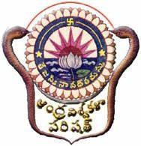
ANDHRA UNIVERSITY
Internal Quality Assurance Cell
Presents

समाचार
SAMACHAAR
VOLUME 2 1ST April 2022 – 30th June 2022 ISSUE 2

Namaste….. AU fraternity!!! We have entered into the 2nd Quarter of 2022. Andhra University is buzzling with various events organized by the constituent colleges. This Quarter has witnessed the grandeur of Andhra University Foundation Day celebrations on 26th April, 2022 under the leadership of our Hon'ble Vice Chancellor.
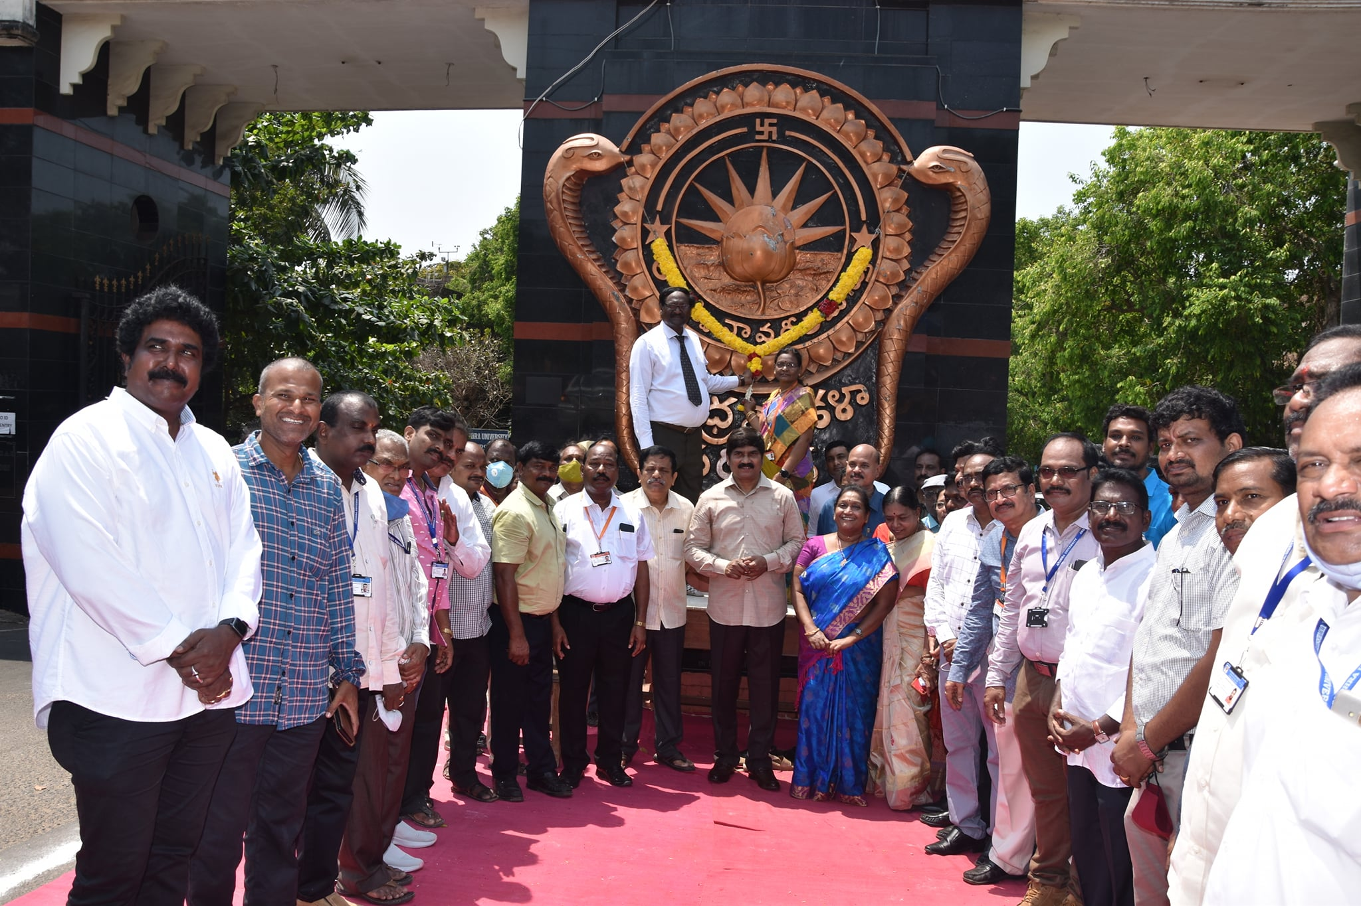
Andhra University Foundation Day Celebrations

SEMINARS/CONFERENCES/WORKSHOPS/ WEBINARS CONDUCTED (NATIONAL / INTERNATIONAL) : The following is the list of webinars conducted by all the constituent colleges of AU during 1st April 2022 – 30th June 2022:
A.U. College of Engineering : (16)
National : Department of Electrical Engineering :
 | Webinar on "Application of Classroom Knowledge in an Industry: Real Learning in Action." | 26th April, 2022
 | Webinar on "Functions of Investment Bank - A high level overview." | 30th April, 2022
 | Webinar on "Role of Engineer in Public Service". | 20th May, 2022
 | Webinar on "Opportunities & Challenges in Petroleum Refining Sector". | 18th June, 2022
 | Webinar on "An overview of Big Data Technologies". | 24th June, 2022
 | Webinar on "Development of Armaments in DRDO, India". | 27th June, 2022
International : Department of Electrical Engineering :
 | Webinar on Ask Me Anything Session with Harish Jayanti". | 05th April, 2022
 | Webinar on "Careers in FMCG Supply Chain". | 07th April, 2022
 | Webinar on "AI in Practice ". | 11th April, 2022
 | Webinar on "Growing and Succeeding in the technology industries". | 16th April, 2022
 | Webinar on "Impact of Digital Transformation in the Energy Industry: What\'s Next?". | 19th April, 2022
 | Webinar on "Critical Success Factors for the Career Ahead ". | 06th May, 2022
 | Webinar on "Build Your Breakthrough Career". | 10th May, 2022
 | Webinar on "Use of Big Data & Analytical approach to Financial Trading in rapidly Electrifying Energy Markets". | 17th May, 2022
 | Webinar on "Future of Technology and Engineer\' s Role". | 25th May, 2022
 | Webinar on "Build your knowledge Build your career". | 09th June, 2022

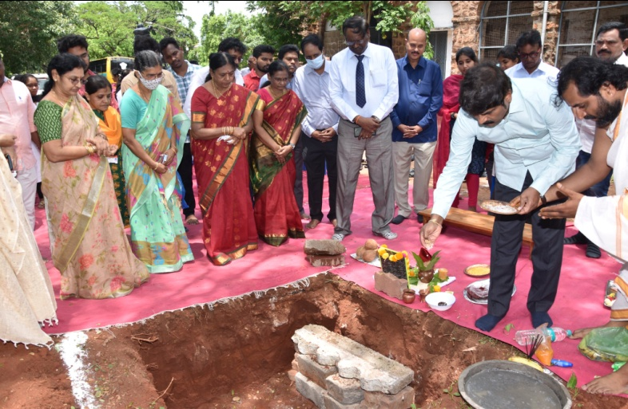
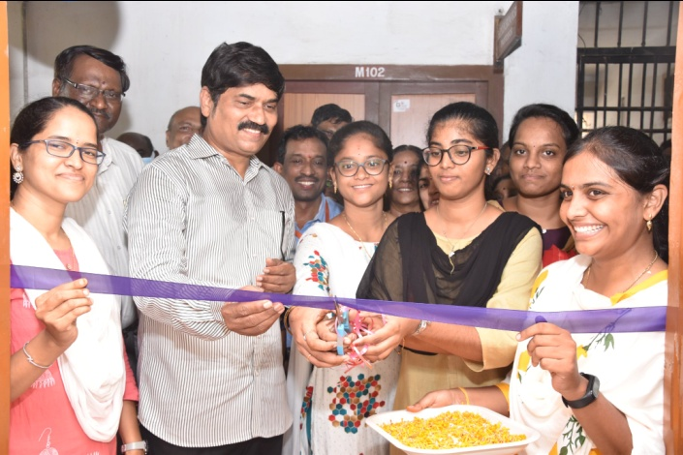
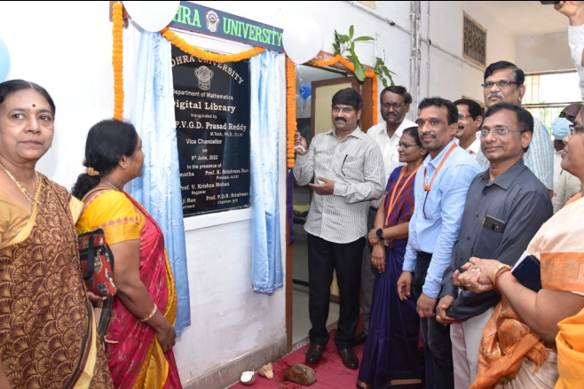
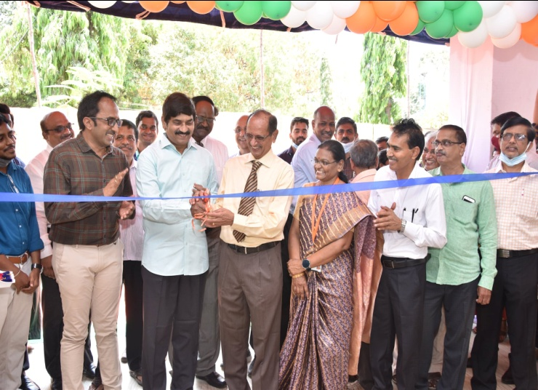
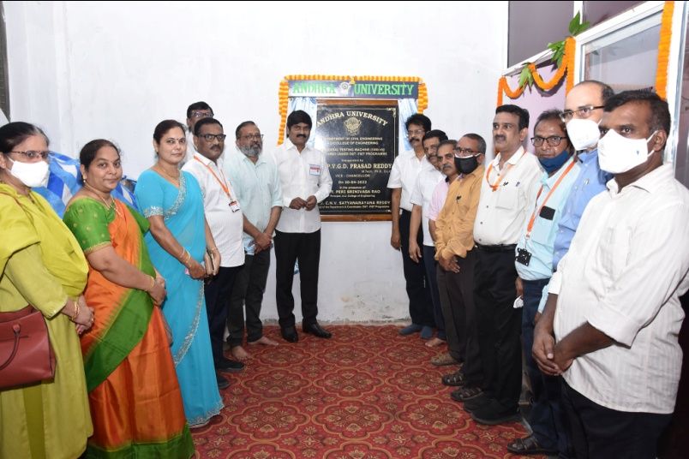
Computer Laboratory
Digital Library
TECH HORIZON of AU – IIPE @
AU College of Engineering (A)
Universal Testing Machine
INAUGURATION OF NEW OFFICE’S & BUILDINGS :
- Inauguration – Universal Testing Machine (1000 KN) @ Dept. of Civil Engineering.
- Inauguration - TECH HORIZON of AU – IIPE @ AU College of Engineering (A).
- Inauguration of Digital Library @ Department of Mathematics, AU.
- Inauguration of Computer Laboratory @ Department of Mathematics, AU.
- Bhoomi Pooja celebration to install the statue of Shri Alluri Sitarama Raju.

Bhoomi Pooja Celebration to install the statue of Shri Alluri Sitarama Raju.

MAJOR EVENTS held during April - June 2022 in AU
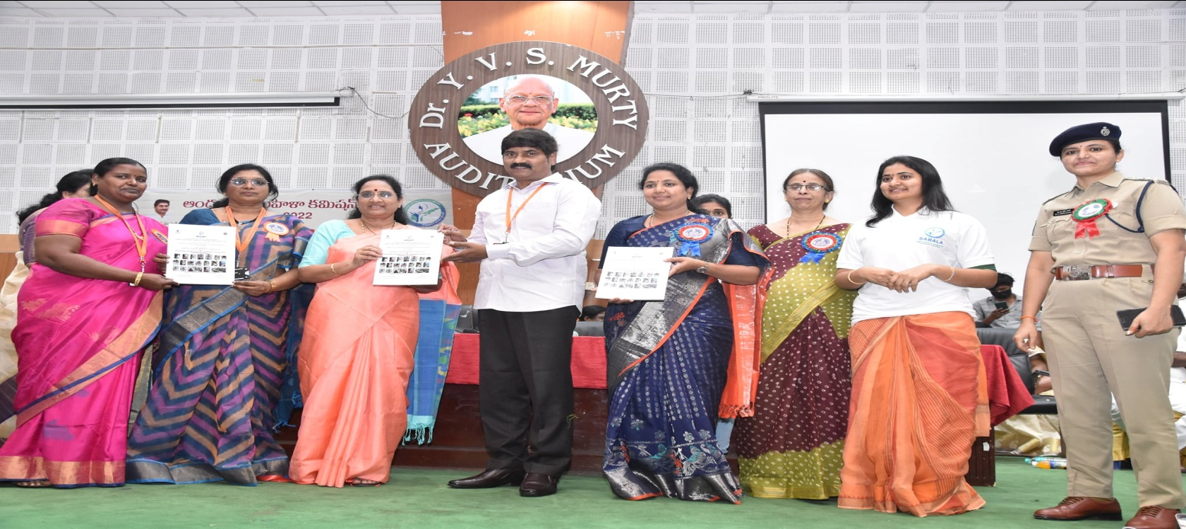

Regional Conference - ‘సబల - ఆమెకు అండగా ఆంధ్రప్రదేశ్’ organised by A.P. Women’s Commission @ AU Campus

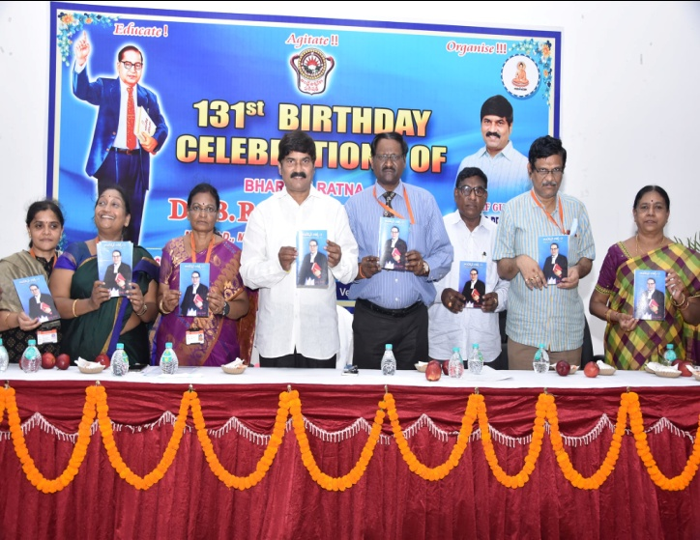
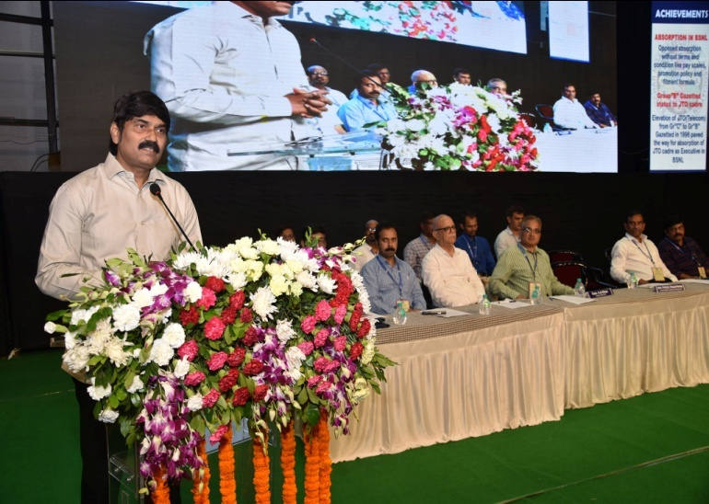

Inauguration of XXXI All India Conference of Sanchar Nigam Executives’ Association @ Andhra University
131st Birthday Celebrations of
Dr. B.R. Ambedkar College of Law

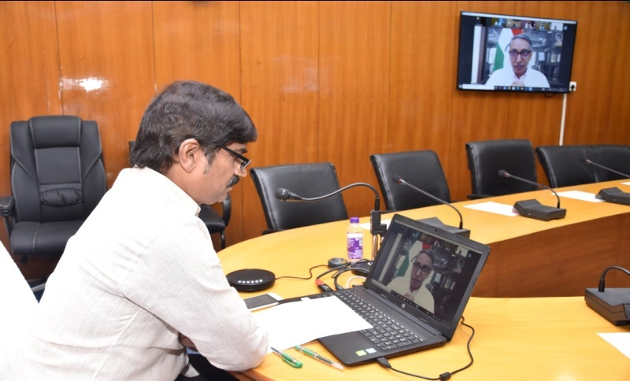

Andhra Pradesh Vice-Chancellors Meet – With UGC Chairman

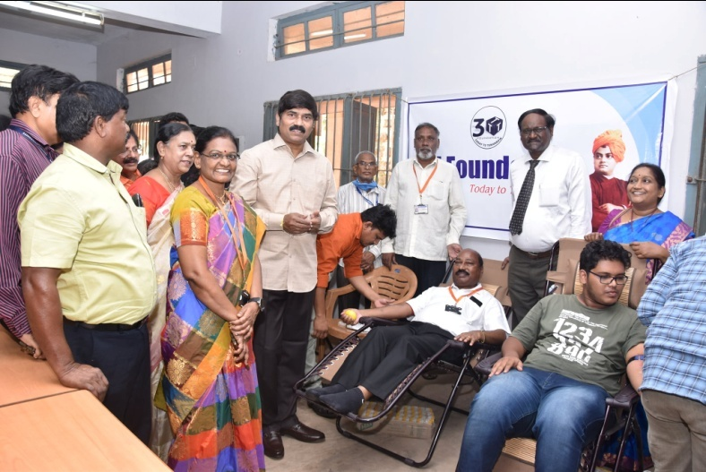
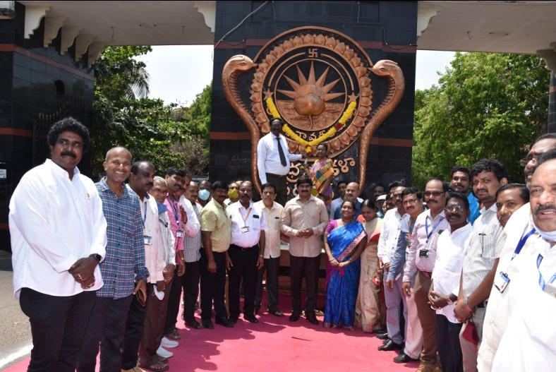
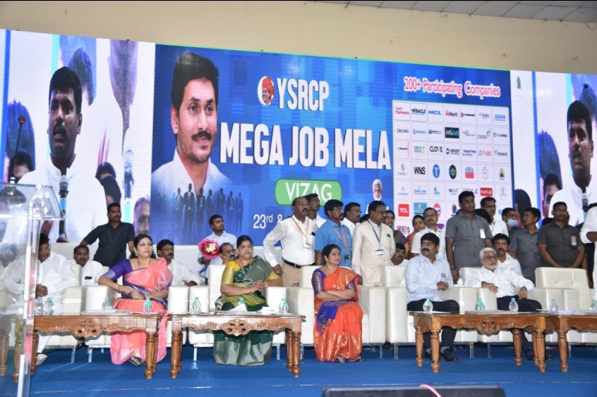
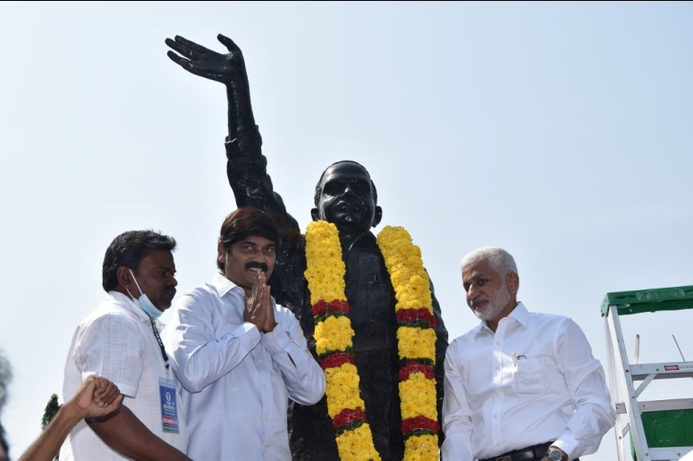
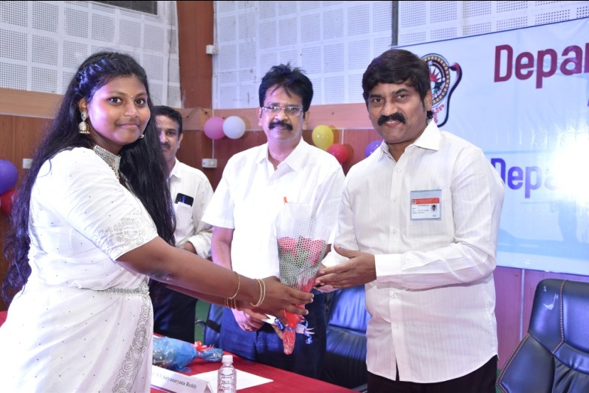
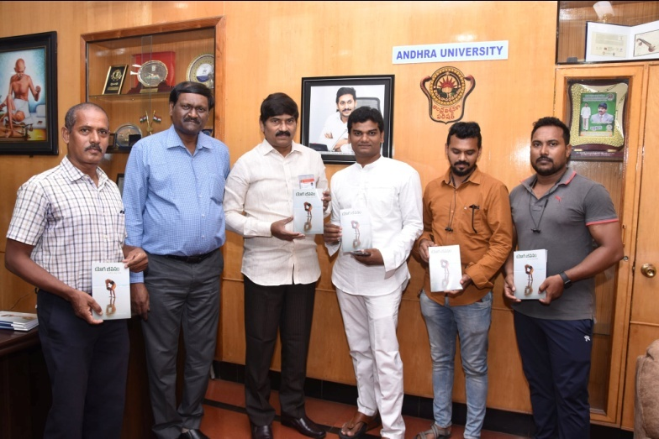
Foundation Day Celebrations & Blood Donation Camp at Andhra University
Mega Job Mela @ AU – Organised by YSRCP – Social responsibility initiative
Garlanding Statue of Late Shri Y.S.R.
Andhra University
Department Day Celebrations 2022 of Dept. of Civil Engineering
Book Release – యోగ జీవనం authored by Sri Baburao, International Yoga Master
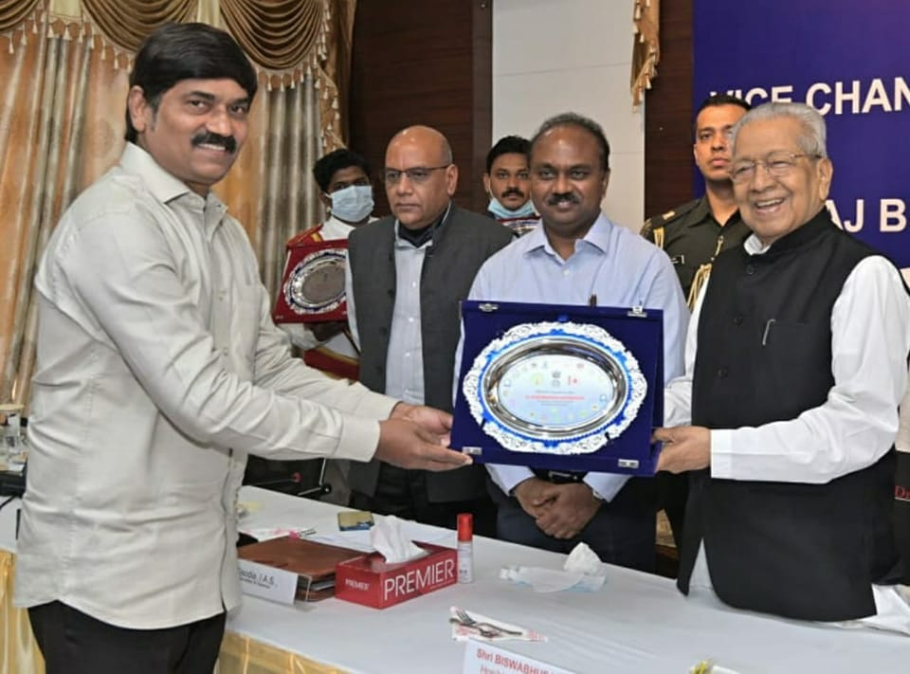
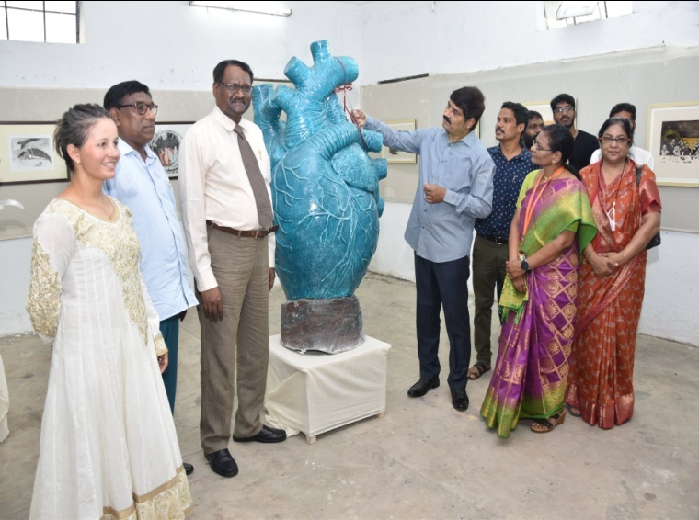
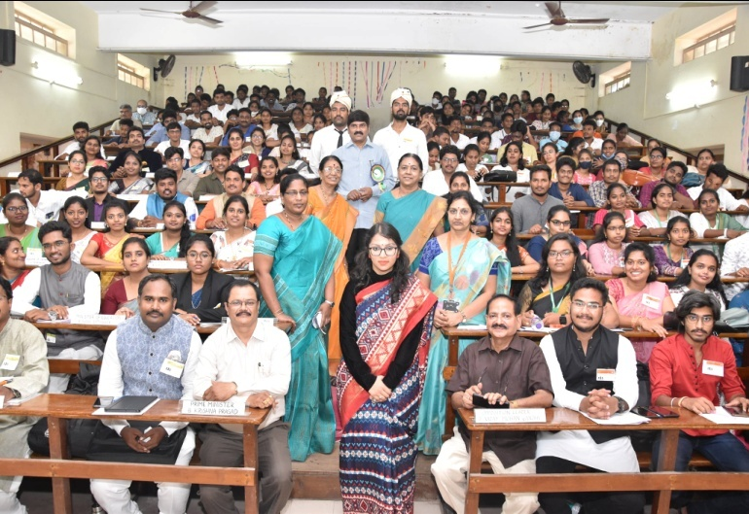
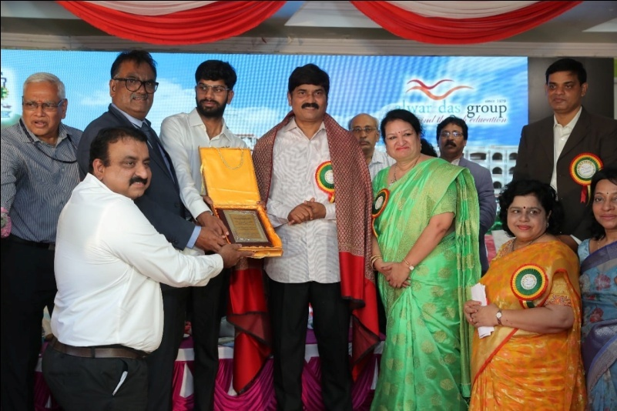
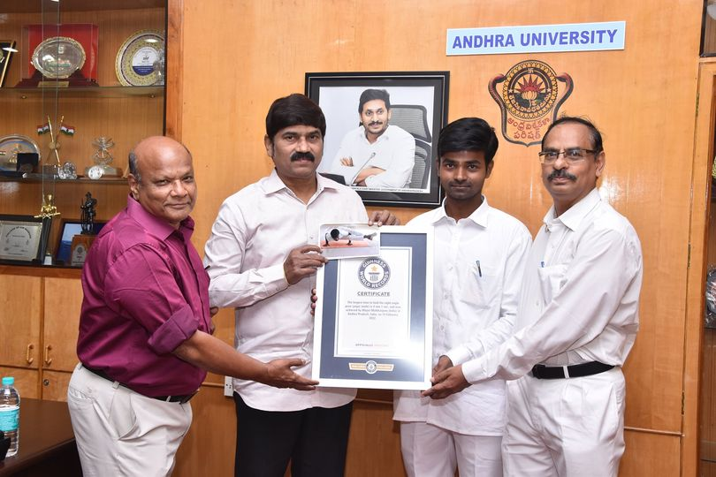
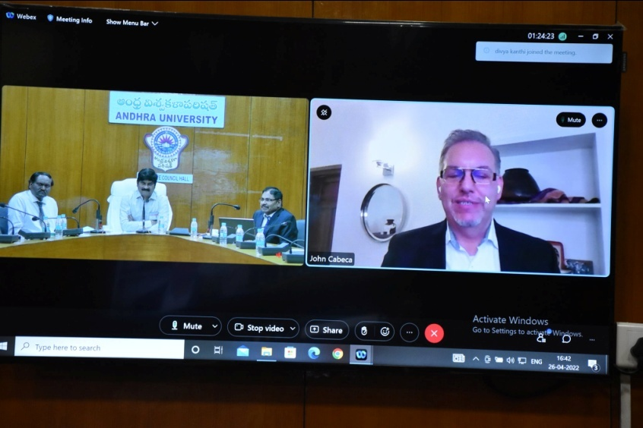
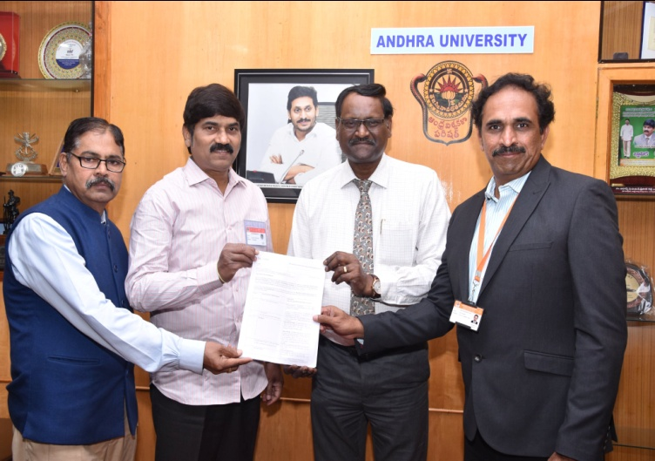
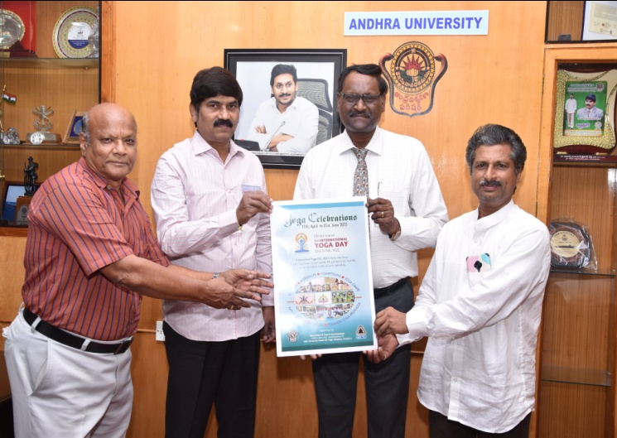
Inauguration – EMBODIED 2022 – Annual Art Exhibition by MFA & BFA Students @ Dept. of Fine Arts, Andhra University
Receiving Memento from His Excellency and Hon Governer at Vice-Chancellors conference at Raj Bhavan on 5th May
Youth Parliament @ Dr.B.R. Ambedkar College of Law, AU
Inauguration of Two Day Multi-Disciplinary International Conference on “Emerging Trends and Technologies in Engineering, Pharmacy and LangLit” (ETTEPL) @ Sanketika Vidya Parishad Engineering College
International Webinar on IP and Youth: Innovating for a Better Future
Congratulations to the AU Student, Mr. Mejari Mallikarjuna for achieving a place in Guinness World Records for holding the eight-angle Yoga pose for 4 Minutes and 01 Sec.
Sanction of Inclusive Technology Business Incubator (i-TBI) under DST with a grant of INR 5 Cr to AU College of Engineering
Poster Release – Yoga Celebrations – on the eve of 8th International YOGA Day on 21th June 2022
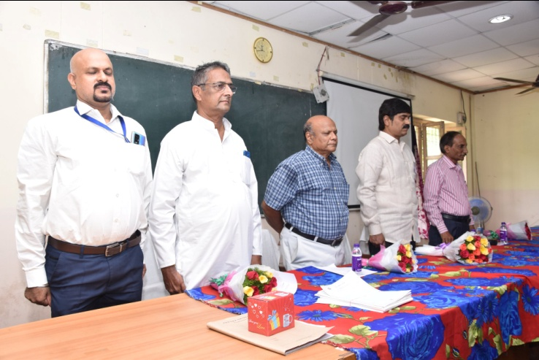
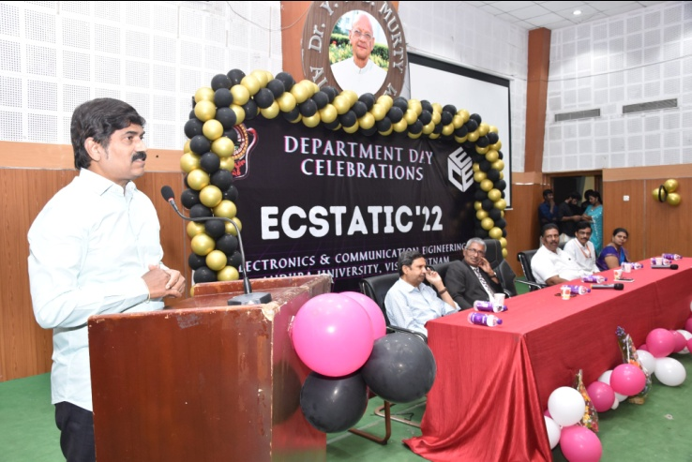
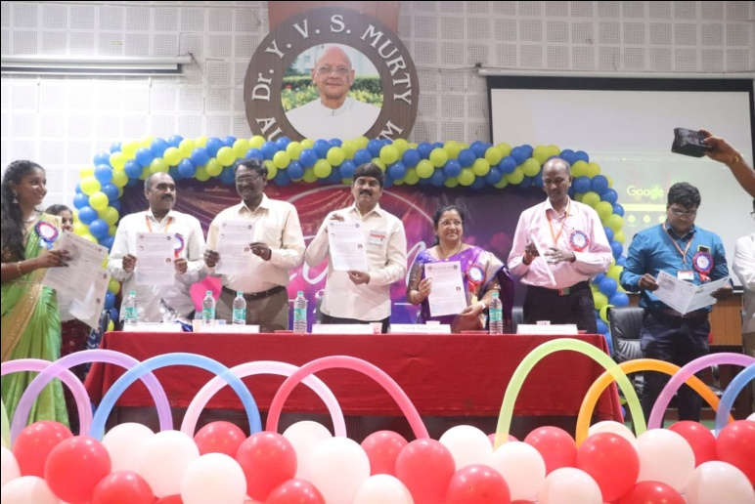
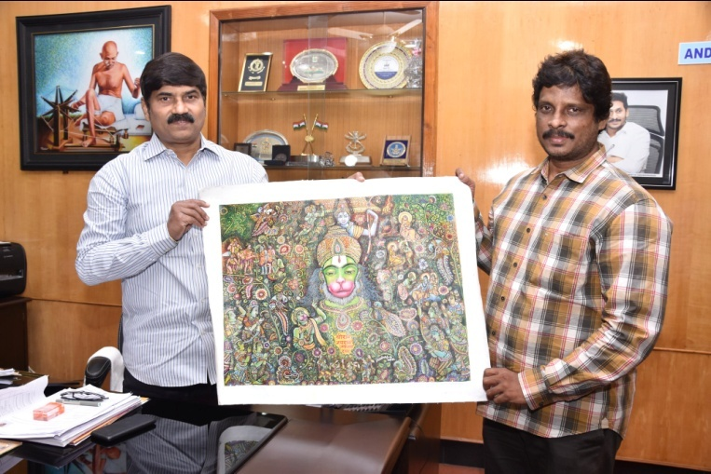
Pre-Release Course – “Diploma in Yoga Instructor” for Defence participants @ Centre for Defence Studies, Andhra University – Passing out ceremony
Department Day Celebrations “ECSTATIC - 2022” of Dept. of Electronics and Communication Engineering
66th Department Day Celebrations “ECLAN - 2022” of Dept. of Electrical Engineering
Congratulations to Mr. Srinivasa Rao Kanumuri, a student of MFA (2014-2016), Andhra University for achieving 1st position in the Virtual International Painting Competition “SANKATMOCHAN” jointly organised by ArtsCrafts & Starglobal.
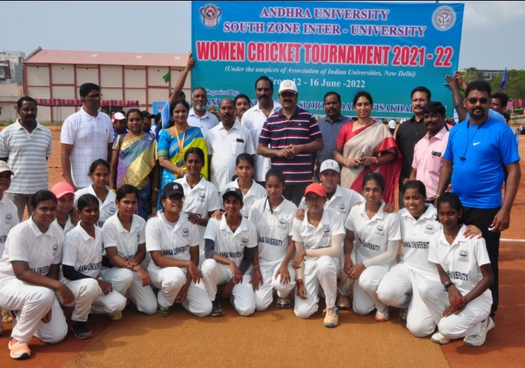
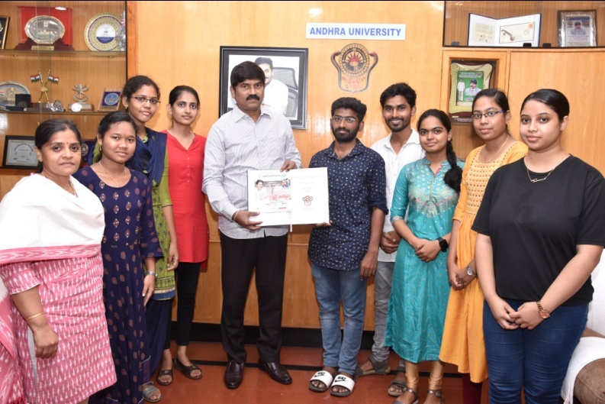
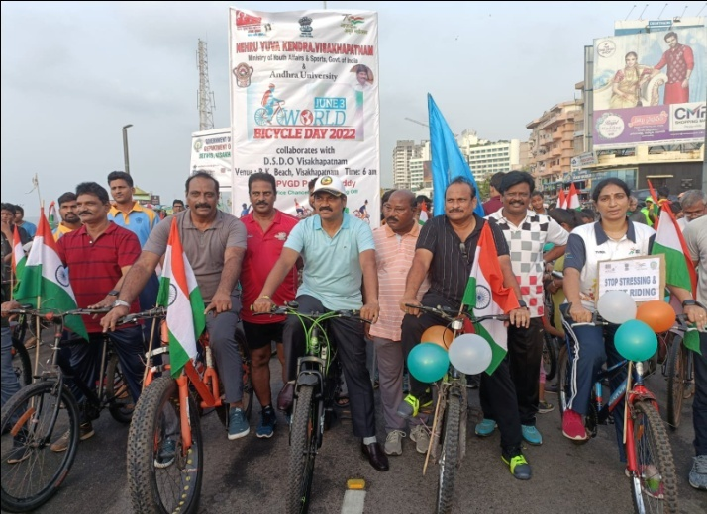
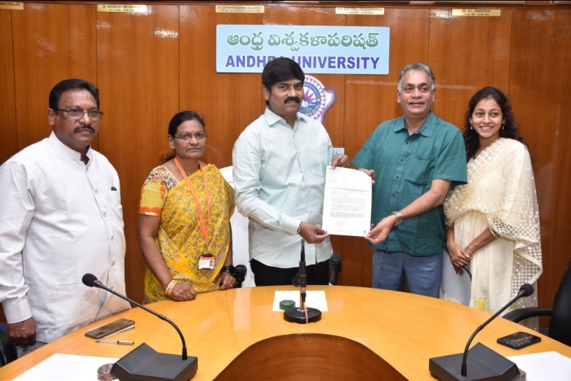
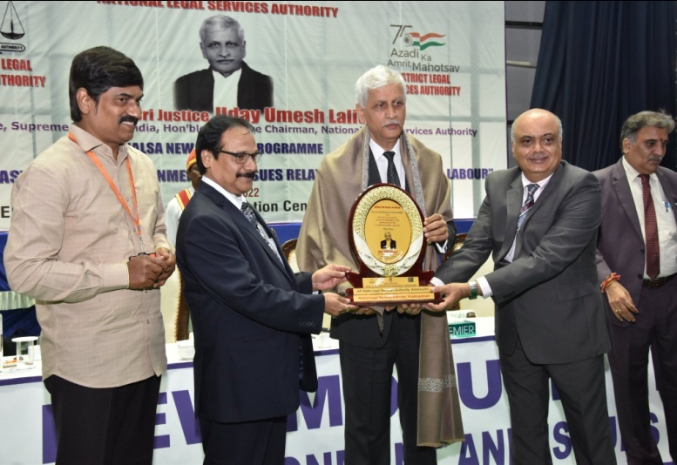
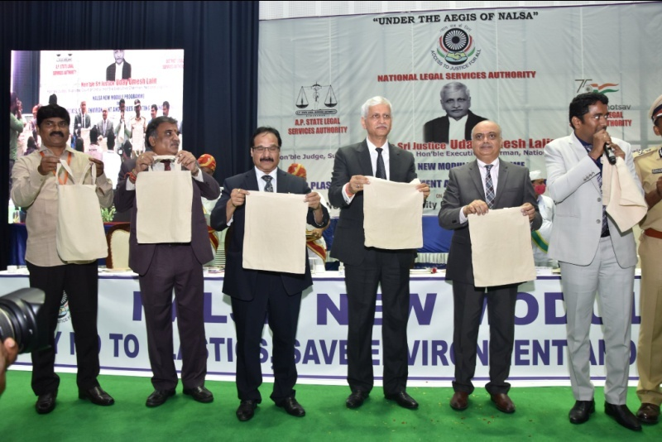
South Zone Inter-University Women Cricket Tournament 2021- 2022 – Organised by Andhra University
“Determination of Folic Acid Content in Selected Brands of Fortified Rice by RP-HPLC” a Report submitted to the Government of Andhra Pradesh by the students of “AU College of Pharmaceutical Sciences”
World Bicycle Day – 2022 organized by Andhra University in collaboration with Nehru Yuva Kendra and D.S.D.O., Visakhapatnam
CSR Initiative by Shri A. Satyanarayana, Managing Director, Coromandel Paints Pvt. Limited to Andhra University - Contribution of Rs.9,05,000/-.
NALSA New Module Programme on “Say No to Plastics, Save Environment and Issues relating to Unorganised Labour” @ Andhra University Convention Centre – Chief Guest – Hon’ble Shri Justice Uday Umesh Lalit, Supreme Court of India and Guest of Honour, Hon’ble Shri Justice Prashant Kumar Mishra, Chief Justice, High Court of Andhra Pradesh, and Hon’ble Shri Justice Ahsanuddin Amanullah, Judge, High Court of Andhra Pradesh.
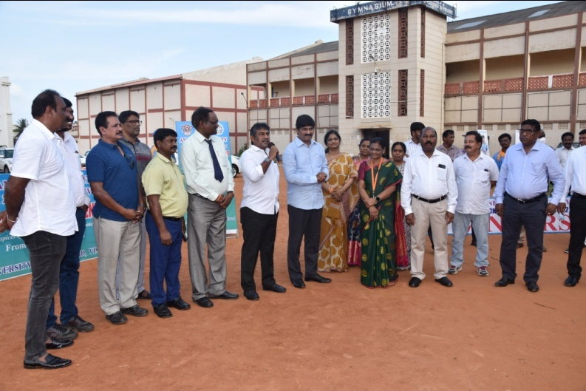
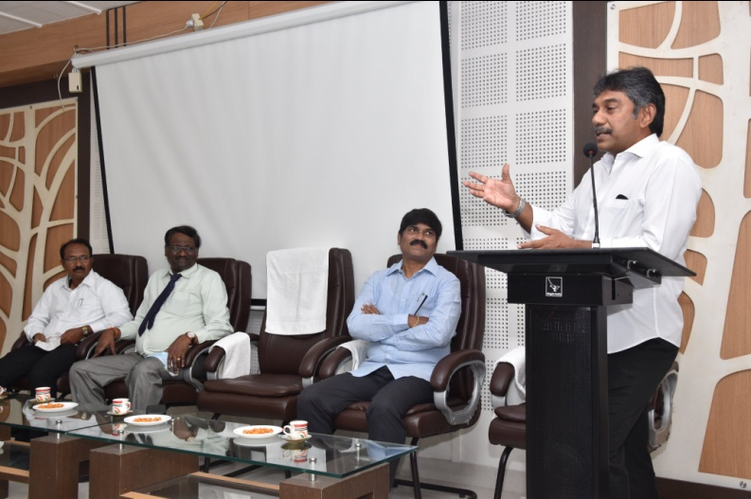
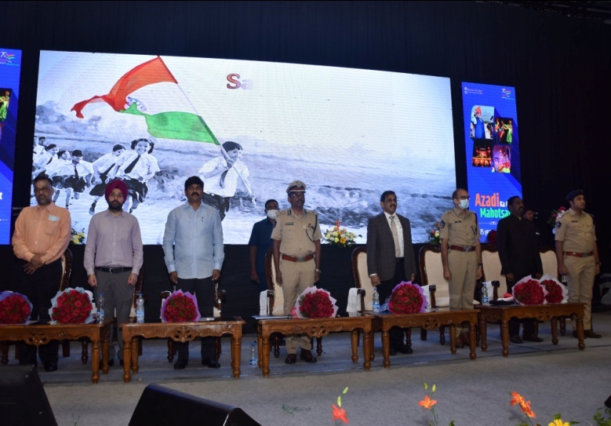
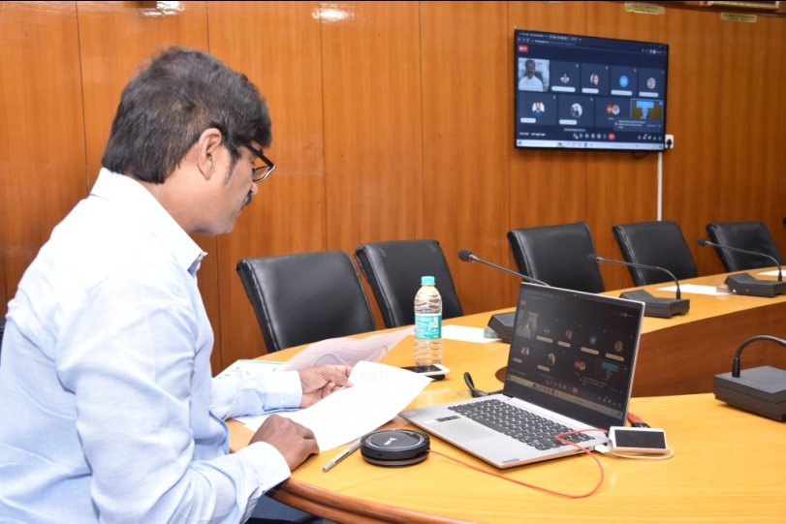
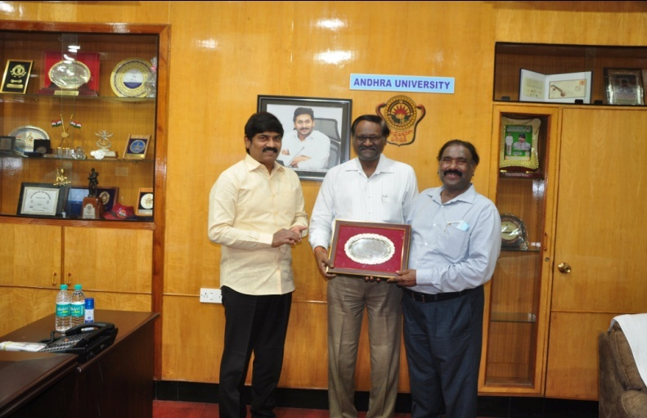
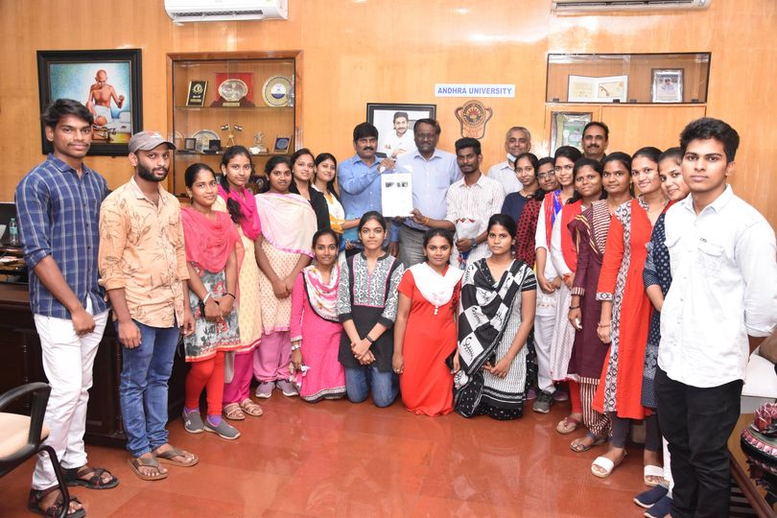
Sri Nedurumalli Ramkumar, Chairman, Board of Community Development through Education (BCDE) interacted with University authorities, Press & Media @ AU on the eve of Focus Group Discussion on “Decentralisation and Ease of Governance” scheduled to be held on 17th June, 2022 at AU.
Prize Distribution – South Zone Inter-University Women Cricket Tournament 2021-22
Chief Guest @ ‘Cyber Safety & National Security: Cyber Apradh se Azadi – Azadi ka Amrit Mahotsav’ organised by Visakhapatnam City Police – Sponsored by Ministry of Home Affairs, Govt. of India
Chief Guest @ National Webinar on ‘The Role of Shat Kriyas in Management of Health & Ailments’ on the occasion of 8th International Yoga Day Celebrations
Congratulating Dr. O.R.M. Rao, General Manager (HR), RINL and Chairman, Indian Society for Training and Development (ISTD), Vizag Chapter for achieving the Best Member Award at the National level by the International Federation of Training & Development
20 students from Andhra University selected for Free Summer Internship – 2022 @ TCABS-E Laboratories
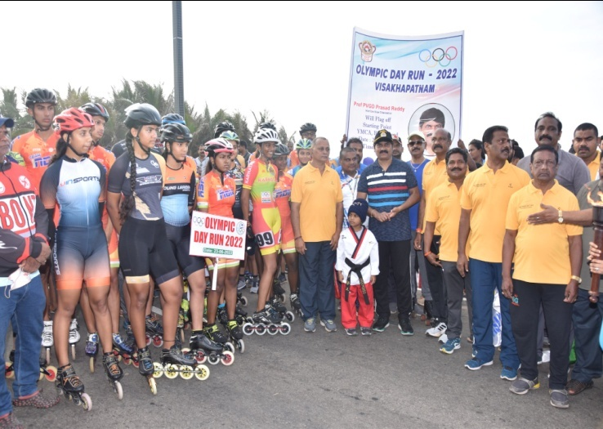
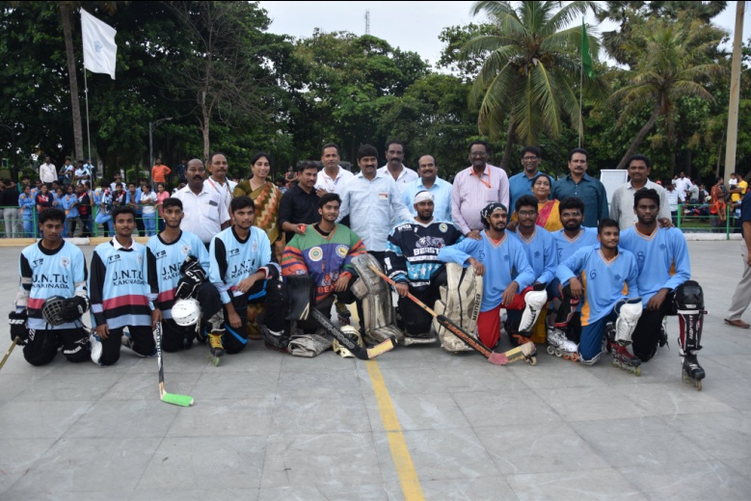
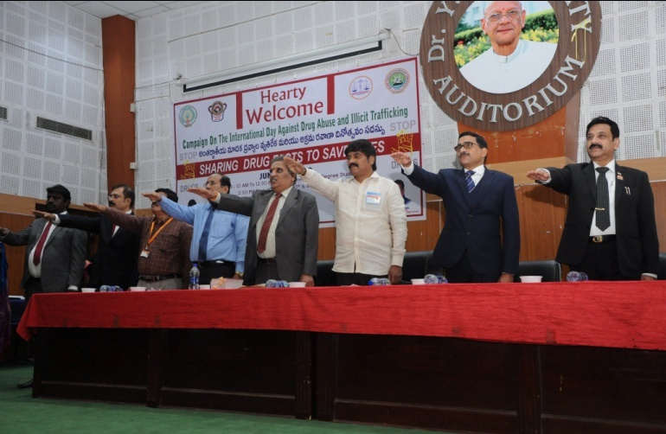
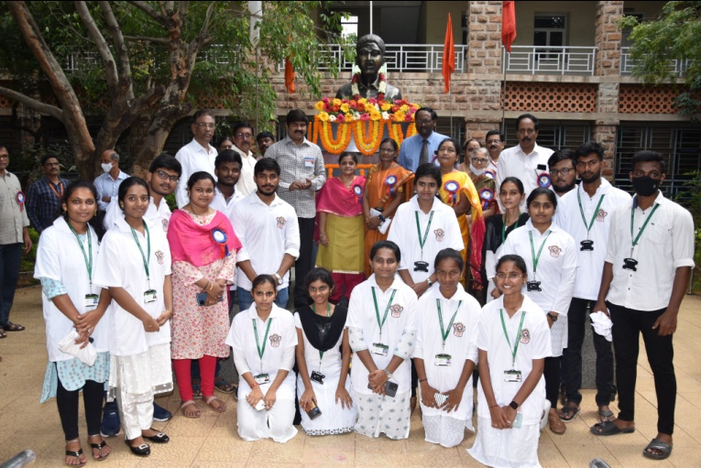
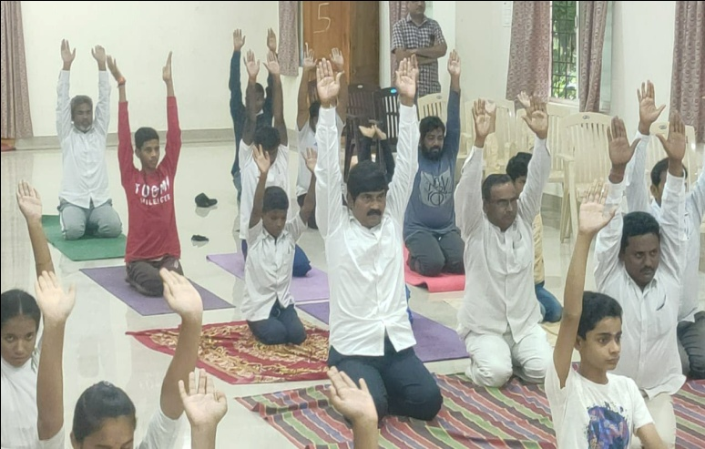
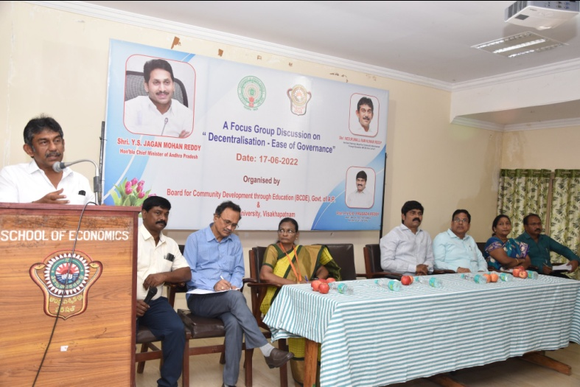
All India Inter-University Roller Sports (Men & Women) and Roller Hockey (Men & Women) Tournaments 2021-22 - Organized by Andhra University
“The International Day Against Drug Abuse and Illicit Trafficking” @ Andhra University
Flagging-off – ‘Olympic Day Run – 2022’ – organised by The Olympic Association and Andhra University Sports Board
Inauguration of 12th Seminar in the National Webinar Series “Industrial Approach – Pharmaceutical Analytical Techniques (IPAT 2021-22) on “Say NO to Plastic – Plastic Free Visakhapatnam” @ AU College of Pharmaceutical Sciences
International Day of Yoga @ Bharateeya Vidya Kendram

Group Discussion on “Decentralization – Ease of Governance” organised by the Board of Community Development through Education (BCDE), Govt. of AP @ Andhra University

Visit of V.I.P's to Andhra University :
- Interaction with Smt. Vasireddy Padma, Chairperson, A.P. Women’s Commission.
- Interaction with AU Alumni - Dr E. Shankara Rao, Former MD & CEO, IFCI Ltd.
- Interaction with Alumni – Ms. Padma Priya Iragavarapu, Vice-President, Center of Data Excellence, AARETE, USA.
- Interaction with Shri Chakravarthi Ayyalasomayajula, Database Specialist, Cedar Sinai Medical Hospitals, Los Angeles, CA.
- Interaction with Dr. S. Upendra Rao, Former CTO of State Bank of India and IT advisor.
- Visit of Shri. V. Vijayasai Reddy to Andhra University.
- Interaction with Mr. Mark Burrell, Regional Public Engagement Specialist, Embassy of the United States of America.
- Interaction with Dr. Rao S. Govindaraju, Bowen Engineering Head of Civil Engineering and Christopher B. and Susan S. Burke Professor, Lyles School of Civil Engineering, Purdue University, USA.
- Interaction with Sri Arun Sharma, Executive Chairman, IR Class – Indian Register of Shipping, Mumbai and Sri K. Sethu Madhavan, CEO, Centre of Excellence in Maritime and Shipbuilding (CEMS), Visakhapatnam.
- Interaction with Surg Capt. P. Soni, Dental Cosmetic Surgeon, Officer-in-Charge, INHS Kalyani Hospital and Lt. Col. Varun Rana, Surgeon, INHS Kalyani Hospital.
- Interaction with Prof. Shalivahan, Director of the Indian Institute of Petroleum & Energy (IIPE), Visakhapatnam.
- Interaction with Shri. Chandra Koduru, General Manager & Head, Academic Interface Programme and Shri. Richard Kind Chatragadda, Senior Consultant & Academic Relationship Manager, TATA Consultancy Services.
- Interaction with Honorary Professor (Emeritus) in the Dept. of Environmental Science, Engineering and Management, College of Engineering – Dr. Prakasam B.S. Tata, Former Head of the EMR Division, Chicago, USA.
- Interaction with Shri. A. Satyanarayana, Managing Director, Coromandel Paints Pvt. Limited.
- Interaction with Prof. Gouri Gargate, Rajiv Gandhi School of Intellectual Property Law, IIT Kharagpur.
- Interaction with Dr. Umesh Mahantshetty, Director, Homi Bhabha Cancer Hospital & Research Centre.
- Interaction with Shri Sanjoy Kumar Guha, Chief Executive Officer and Managing Director South Asia LPG Company Pvt. Ltd., (SALPG), Visakhapatnam.
- Interaction with Shri Suresh Bhagavatula, Professor, Entrepreneurship, IIM Bangalore.
- Interaction with Sri Nedurumalli Ramkumar, Chairman, Board of Community Development through Education (BCDE), Govt. of AP.
- Interaction with the Capt. Edwin Jyothi, Director, Naval Education and Commander, Ms. P. Manorama from Indian Navy HQ, New Delhi.
- Interaction with Sri K. Raghavendra Rao, Advisor, Ramky Pharmacity India Pvt Ltd.
- Interaction with Dr. Andrew Fleming, Deputy High Commissioner and Sri Varun Mali, Deputy Head of Mission, Head of Trade & Investment, British Deputy High Commission, Hyderabad.
- Interaction with Shri Bhikkhu Ananda, General Secretary, Maha Bodhi Society, Bengaluru.

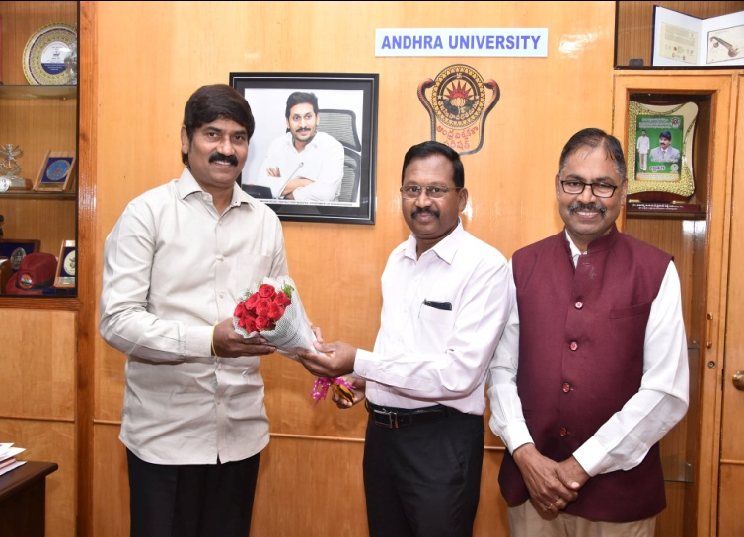
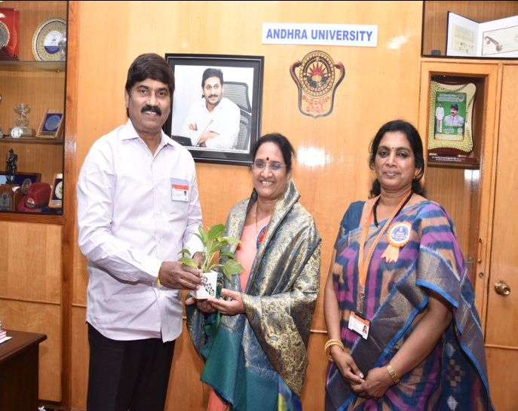
2. Dr E. Shankara Rao, Former MD & CEO, IFCI Ltd

1 .Smt. Vasireddy Padma, Chairperson, A.P. Women’s Commission

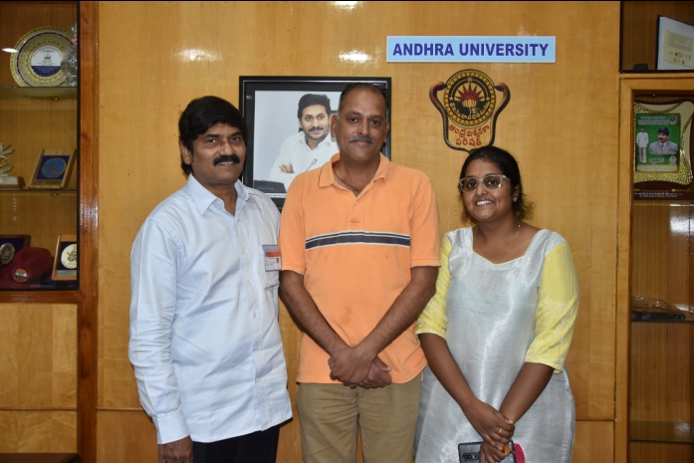
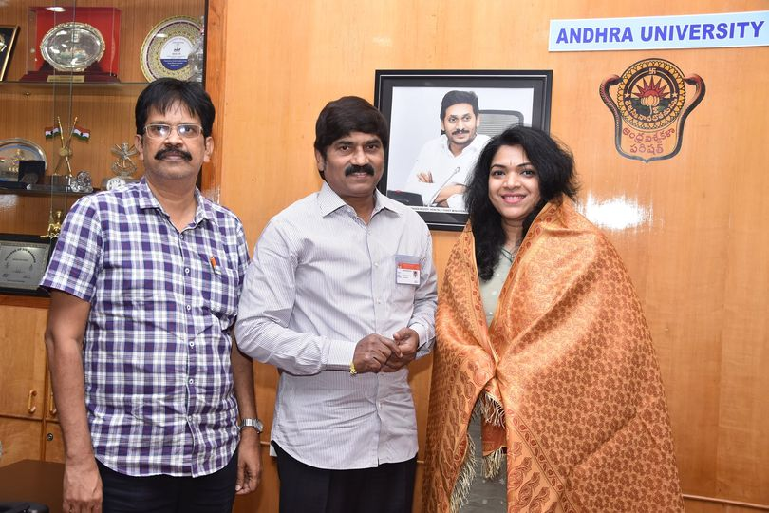

3. Ms. Padma Priya Iragavarapu, Vice-President, Center of Data Excellence, AARETE, USA.

4.Shri Chakravarthi Ayyalasomayajula, Database Specialist, Cedar Sinai Medical Hospitals, Los Angeles, CA.

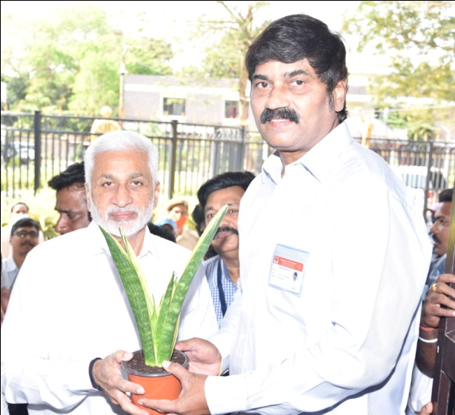
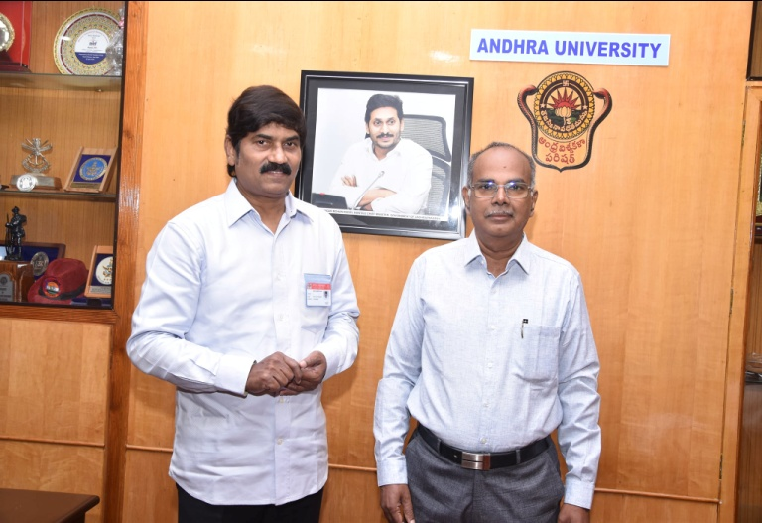
6. Shri. V. Vijayasai Reddy, MP
5. S. Upendra Rao, Former CTO of State Bank of India and IT advisor.

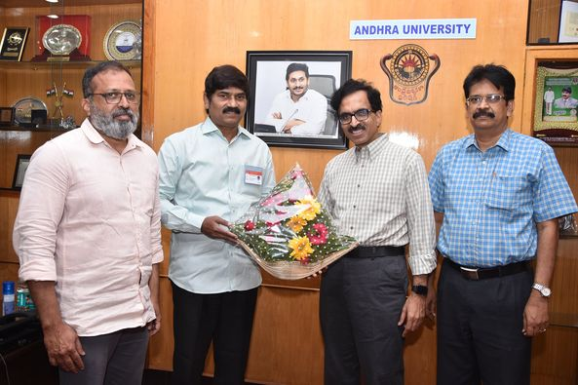
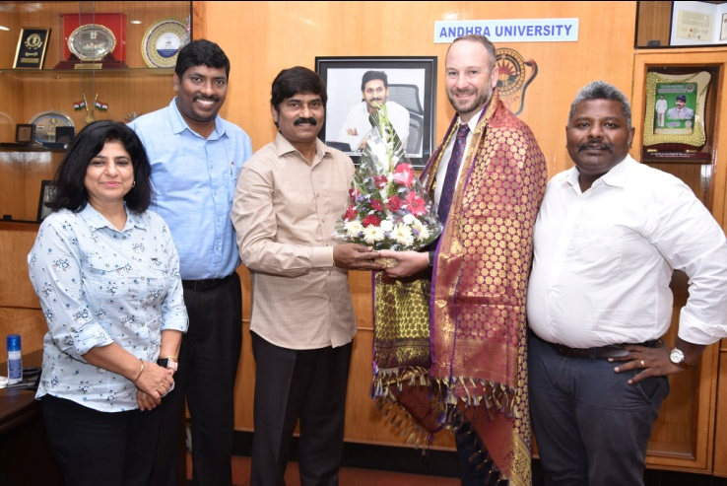
7. Mr. Mark Burrell, Regional Public Engagement Specialist, Embassy of the USA
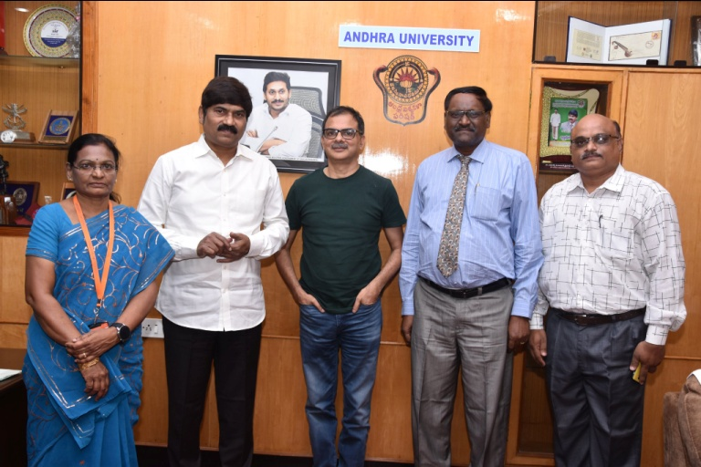
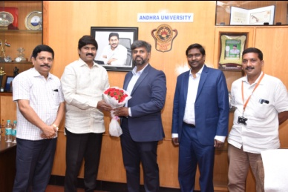
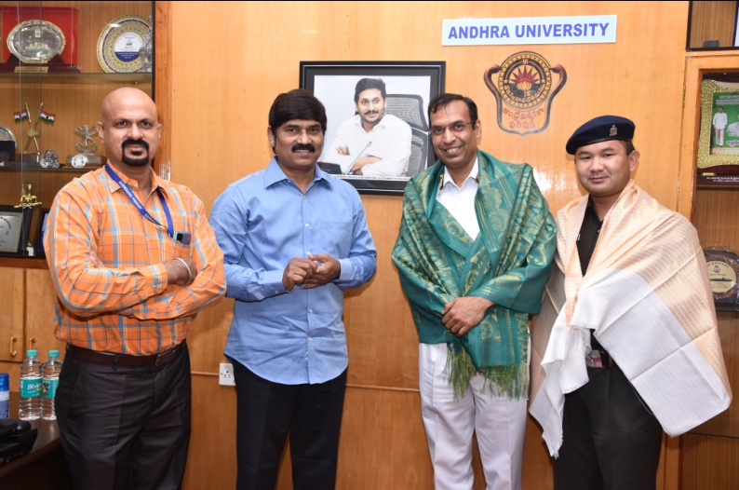
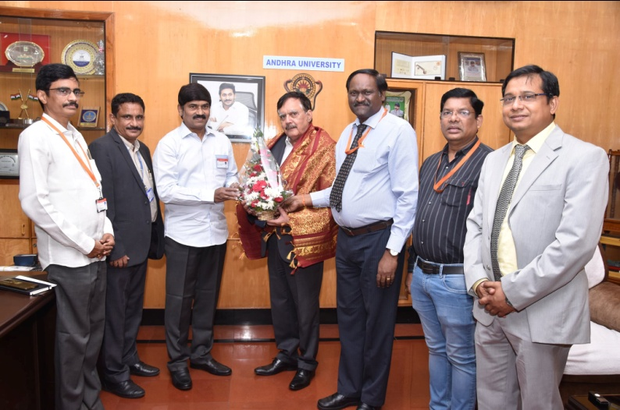
9. Sri Arun Sharma, Executive Chairman, IR Class – Indian Register of Shipping, Mumbai and Sri K. Sethu Madhavan, CEO, Centre of Excellence in Maritime and Shipbuilding (CEMS) Visakhapatnam.
12 Shri. Chandra Koduru, General Manager & Head, Academic Interface Programme and Shri. Richard Kind Chatragadda, Senior Consultant & Academic Relationship Manager, TATA Consultancy Services.
11 Prof. Shalivahan, Director of the Indian Institute of Petroleum & Energy (IIPE), Visakhapatnam
10 Surg Capt. P. Soni, Dental Cosmetic Surgeon, Officer-in-Charge, INHS Kalyani Hospital and Lt. Col. Varun Rana, Surgeon, INHS Kalyani Hospital
8. Dr. Rao S. Govindaraju, Bowen Engineering Head of Civil Engineering and Christopher B. and Susan S. Burke Professor, Lyles School of Civil Engineering, Purdue University, USA.

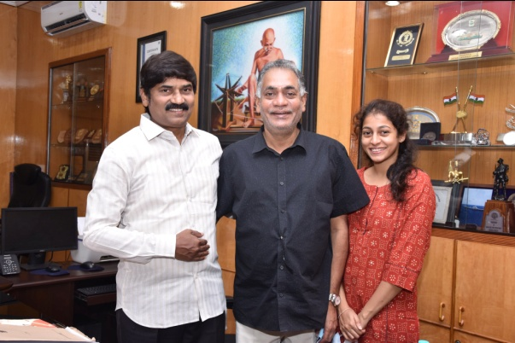
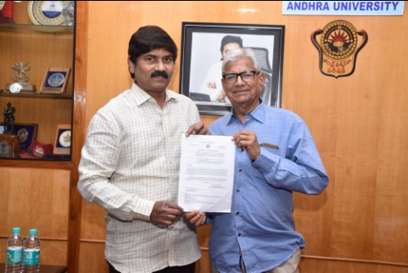
24 Shri. A. Satyanarayana, Managing Director, Coromandel Paints Pvt. Limited.
13. Honorary Professor (Emeritus) in the Dept. of Environmental Science, Engineering and Management, College of Engineering – Dr. Prakasam B.S. Tata, Former Head of the EMR Division, Chicago, USA.
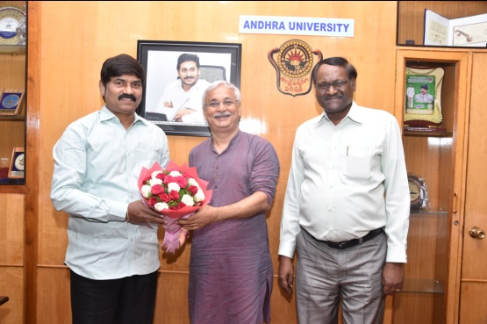
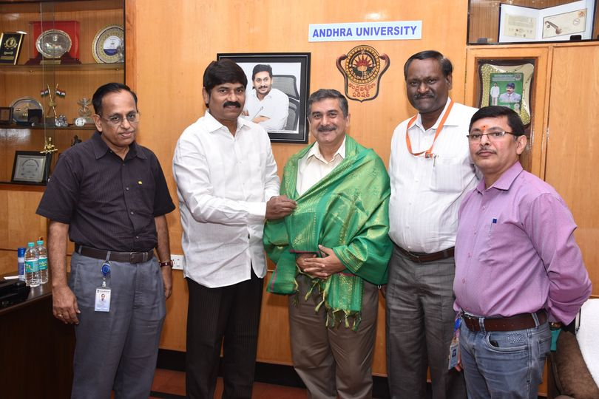
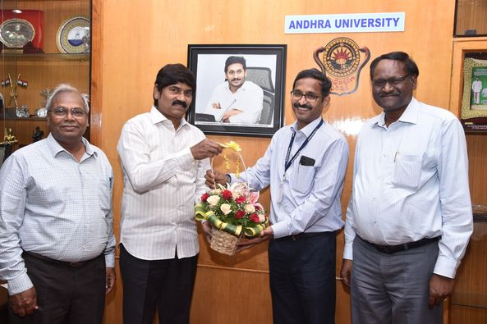
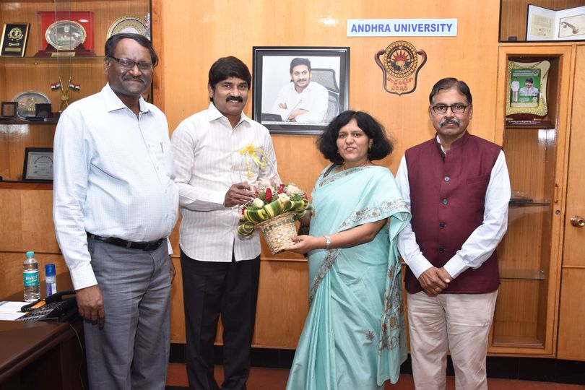
18. Shri Suresh Bhagavatula, Professor, Entrepreneurship, IIM Bangalore.
17. Shri Sanjoy Kumar Guha, Chief Executive Officer and Managing Director South Asia LPG Company Pvt. Ltd., (SALPG), Visakhapatnam.
16. Dr. Umesh Mahantshetty, Director, Homi Bhabha Cancer Hospital & Research Centre.
15. Prof. Gouri Gargate, Rajiv Gandhi School of Intellectual Property Law, IIT Kharagpur.

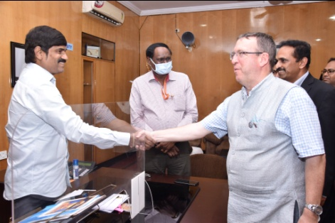
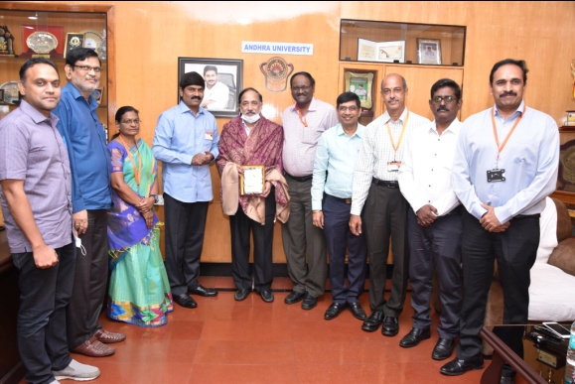
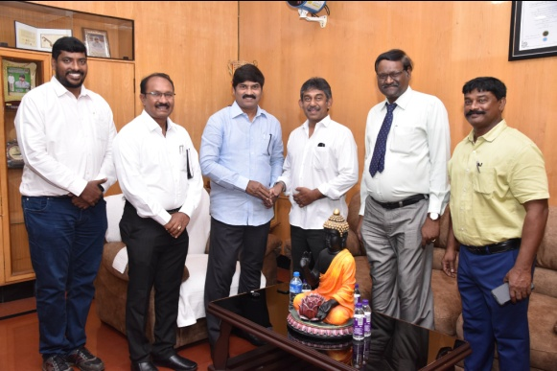
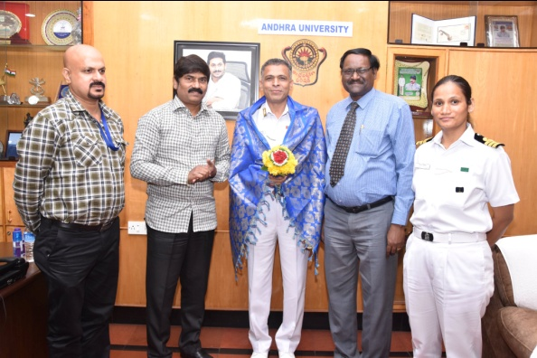
21. Sri K. Raghavendra Rao, Advisor, Ramky Pharmacity India Pvt Ltd.
22. Dr. Andrew Fleming, Deputy High Commissioner and Sri Varun Mali, Deputy Head of Mission, Head of Trade & Investment, British Deputy High Commission, Hyderabad.
19. Sri Nedurumalli Ramkumar, Chairman, Board of Community Development through Education (BCDE), Govt. of AP.
20. Capt. Edwin Jyothi, Director, Naval Education and Commander, Ms. P. Manorama from Indian Navy HQ, New Delhi.
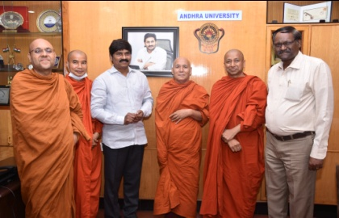

23. Shri Bhikkhu Ananda, General Secretary, Maha Bodhi Society, Bengaluru.
TRIBUTE'S:

- Tributes to Dr. Babu Jagjivan Ram - 115th Birthday Celebrations.
- Tributes to Mahatma Jyotirao Phule – 195th Birthday Celebrations.
- Tributes to Bharath Ratna Dr. B.R. Ambedkar – 131st Birthday Celebrations @ Dr. B.R. Ambedkar College of Law.

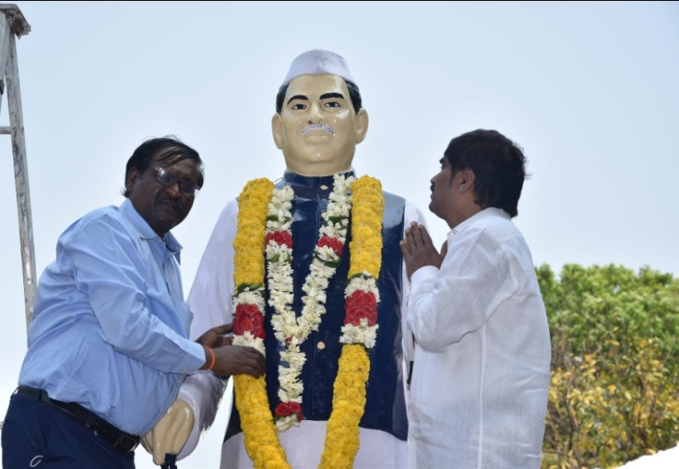

Dr. Babu Jagjivan Ram

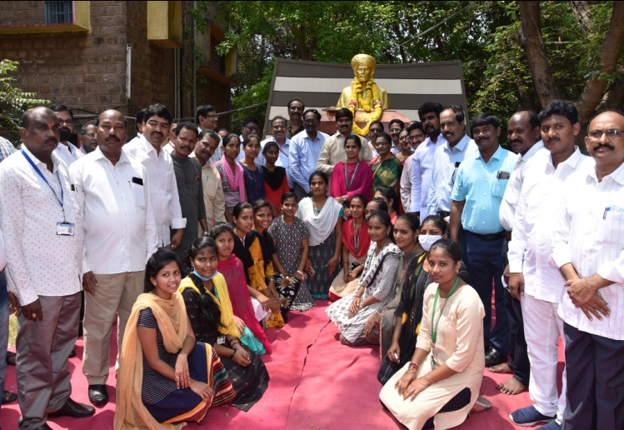

Mahatma Jyotirao Phule

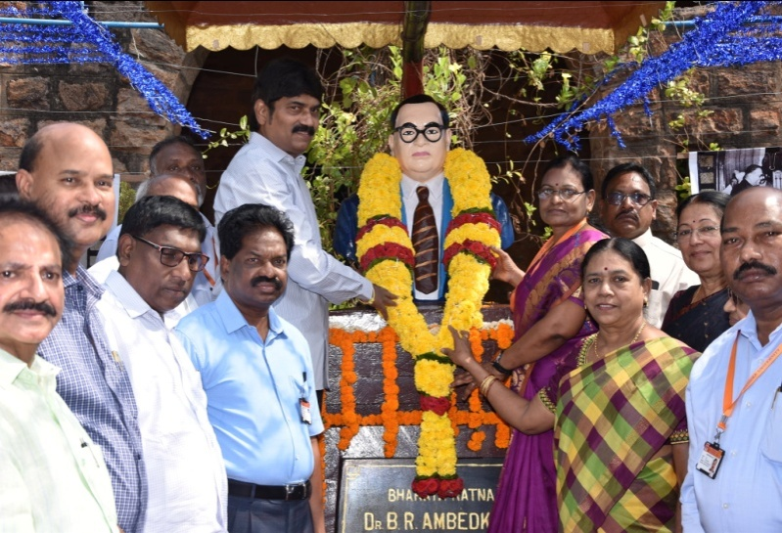

Bharath Ratna Dr. B.R. Ambedkar

Faculty Recognition/Awards: Several Faculty have been awarded with various Prestigious awards and Recognitions at both State and National Level as given below:
S.No | Name of the faculty | Dept/College | Recognition / Award Received
1 | Prof. Capt. Ramakrishna | Department of Mathematics | Jateeya Ratna Ugadi Puraskaram
2 | Prof.H.Purushotham | IPR Cell | IP Recognition Award

Number of Ph.D’s/M.Phils awarded during this period:

Sl.No | Name of the College | Ph.D.  Awarded | M.Phil.  Awarded
01. | College of Arts & Commerce | 49 | 03
02. | College of Science & Technology | 36 | 02
03. | College of Engineering(A) | 22 | --
04. | College of Pharmaceutical Sciences | 02 | --
05. | Dr.B.R.Ambedkar, College of Law | 05 | --
Total : |  | 114 | 05

MoU’s Inked between Andhra University and the parties during April 2022 - June 2022.
MOU between Andhra University and King George Hospital - Collaborative teaching and research Programmes in the areas of Pharmacy practice and allied health care fields held on 28-04-2022.
MOU Agreement between Missouri State University and Andhra University - MSU students entering AU’s program held on 04-05-2022.
MOU between Andhra University and Talentedge Education Ventures Pvt. Ltd. Mumbai - Telentedge Education Ventures Pvt. Ltd. Has exclusive rights to support the University with technology and Services in helping the University solicit, enroll students and deliver all the courses under the Directorate of Online Programs offered by A.U. held on 18-05-2022.
MOU Between Andhra University and Talentedge Education Ventures PVT. LTD., with respect to offering Technology & Services to Students of Online programme - Talentedge Education Ventures Pvt. Ltd has exclusive rights to support the University with technology and Services held on 18-05-2022.
MOU between Department of Geo Engineering, A.U and Gait Labs India Private Limited - Climate change presents worldwide challenges and risks to environment and economies, impacting human health, increasing extreme weather events, threatening natural resources, and triggering forced migration of populations held on 19-05-2022.
MOU between for creation/functioning of Dr. Ambedkar Chair in A.U. Vsp and Dr. Ambedkar Foundation, Ministry of Social Justice & Empowerment, Govt. of India, New Delhi - Dr. Ambedkar left an indelible impression in the history of India as a messiah who unfettered the oppressed masses and secured human rights for millions of weaker and oppressed classes that were path-breaking held on 22-04-2022.
MoU between A.U. and Valluri Technology accelerators Pvt. Ltd., Bangalore - Collaboration between VTA and Andhra University may be of joint interest to both organizations held on 27-05-2022.
MoU between Directorate of Sainik Welfare A.P and A.U for award of Graduation Certificate in Physical Education (B.P.Ed) to Eligible Ex-Servicemen - Collaboration between Directorate of Sainik Welfare, A.P. and A.U. for academic and technical progression of ex-Servicemen held on 16-06-2022.
MoU between A.U. Visakhapatnam and Maha Bodhi Society, Bangalore - Maha Bodhi Society (MBS), Bengaluru, is a Buddhist charitable organization established in1956 by the most venerable Acharya Buddharakkhita with the main objective of putting into practice the teachings of Bhagawan Buddha held on 17-06-2022.
MoU on Customised M.Tech to Naval officer - Collaboration with DRDO is rolling out the new academic programs “M.Tech. in Defence Technology and M.Sc. in Strategic Studies & International Relation” held on 23-06-2022.
MoU between A.U. and Talentedge Education Ventures PVT. LTD. - CSC Academy is seeking for few online certificate courses as mentioned in the annexure to this MoU held on 24-06-2022.

Student Achievements:
College of Science & Technology | Campus Placements - 570+ students got placements from AU College of Science & Technology in the Academic Year 2021-22
College of Arts & Commerce. | Campus Placements - Dept. of Commerce & Management Studies – Management Trainees (MHRM) in Aditya Birla’s UltraTech Cement Limited
 | Mr. Venkatesh Shitti, for securing placement in - Capgemini Technology Services India Ltd. as Senior Consultant/C1 – Rs.15.00 Lakhs p.a. Package
College of Engineering (A) | Students of Dept. of Architecture, Selected for “Saint-Gobain Architecture Student Contest” @ Poland
 | Ms. Thota Vasantha Mahalakshmi for achieving top rank in M.Tech (Structures), Dept. of Civil Engineering, Andhra University.
Hon’ble Vice Chancellor, Prof.P.V.G.D. Prasad Reddy encouraged all the students and
Congratulated them for making Andhra University proud.

I take this platform to request all our faculty members to regularly fill in the Governors Data portal monthly and thank all of you for your support. Further, for providing any information related to the newsletter for the next quarter(1st July, 2022 to 30th September, 2022) please do mail to iqac@andhrauniversity.edu.in or auiqac2005@gmail.com.

