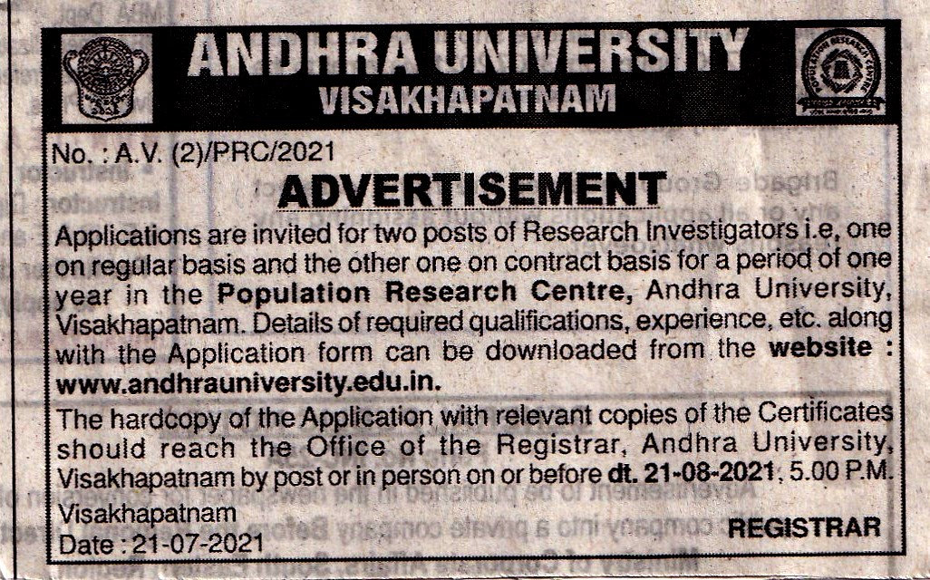

DETAILS OF QUALIFICATIONS, EXPERIENCE, ETC., FOR THE TWORESEARCH INVESTIGATOR POSTS IN THE POPULATION RESEARCH CENTRE, ANDHRA UNIVERSITY, VISAKHAPATNAM-530 003 (A.P.)

I. Name of the Post: Research Investigator (on regular basis)
No. of Posts : 01 (one)
Category : Open
Scale of Pay : Rs.25,140 – 73,270 (Revised Pay Scales – 2015)

Important:

The post is temporary and is likely to continue with continuation of the Population Research Centre (PRC) scheme.

- QUALIFICATIONS:

- At least 2nd class Post Graduate degree in Demography / Population Studies / Statistics / Economics / Mathematics / Sociology / Social Work / Psychology / Anthropology / Geography from a recognized Institution/University.

- Knowledge in Computer Applications.

- EXPERIENCE:

3 years’ experience in collection/analysis and report writing.(Relaxable for candidates with higher qualifications). (The posts may be from different disciplines).

II. Name of the Post: Research Investigator (on contract basis for a period of one year)
No. of Posts : 01 (one)
Category : Open
Monthly Consolidated pay: Rs.37,018/- only.

Important:

The engagement of an employee on contract basis will be for a period of one year. If the performance of the employee is satisfactory and there is a need to keep the post filled up after the said period of one year of engagement, the same employee may be engaged on fresh contract for further period of one year, at a time (subject to the total period of engagement not exceeding 3 years).

The engagement will not bestow any right, whatsoever, on the person to be considered for regular employment and ‘this contract can be terminated by either party, without assigning any reason thereof, by giving one month notice’.

- QUALIFICATIONS:

1. At least 2nd class Post Graduate degree in Demography / Population Studies / Statistics / Economics / Mathematics / Sociology / Social Work / Psychology / Anthropology / Geography from a recognized Institution/University.

2. Knowledge in Computer Applications.

- EXPERIENCE:

3 years’ experience in collection/analysis and report writing.(Relaxable for candidates with higher qualifications). (The posts may be from different disciplines).

2

LAST DATE FOR SUBMISSION OF HARDCOPY OF THE APPLICATIONS BY POST OR IN PERSON ON OR BEFORE 21-08-2021, 5.00 P.M.

The Hardcopy of the filled in Applications i.e. separate Application for each post with relevant copies of certificates should reach the Office of the Registrar, Andhra University, Visakhapatnam-530 003, A.P., by post or in person on or before 21-08-2021, 5.00 P.M.

Further Information can be elicited through:

Prof. B. Muniswamy, Honorary Director, Population Research Centre, 2nd Floor, Statistics Building, Andhra University, Visakhapatnam-530 003 (A.P.).

Office Phone : 0891 – 2755479
0891 – 2844647

E-mail : prcvskp@gmail.com

Prof. V. Krishna Mohan
Registrar
Andhra University
Visakhapatnam-530 003 (A.P.)

