ANDHRA UNIVERSITY
DEPARTMENT OF PHYSICAL EDUCATION AND SPORTS SCIENCES
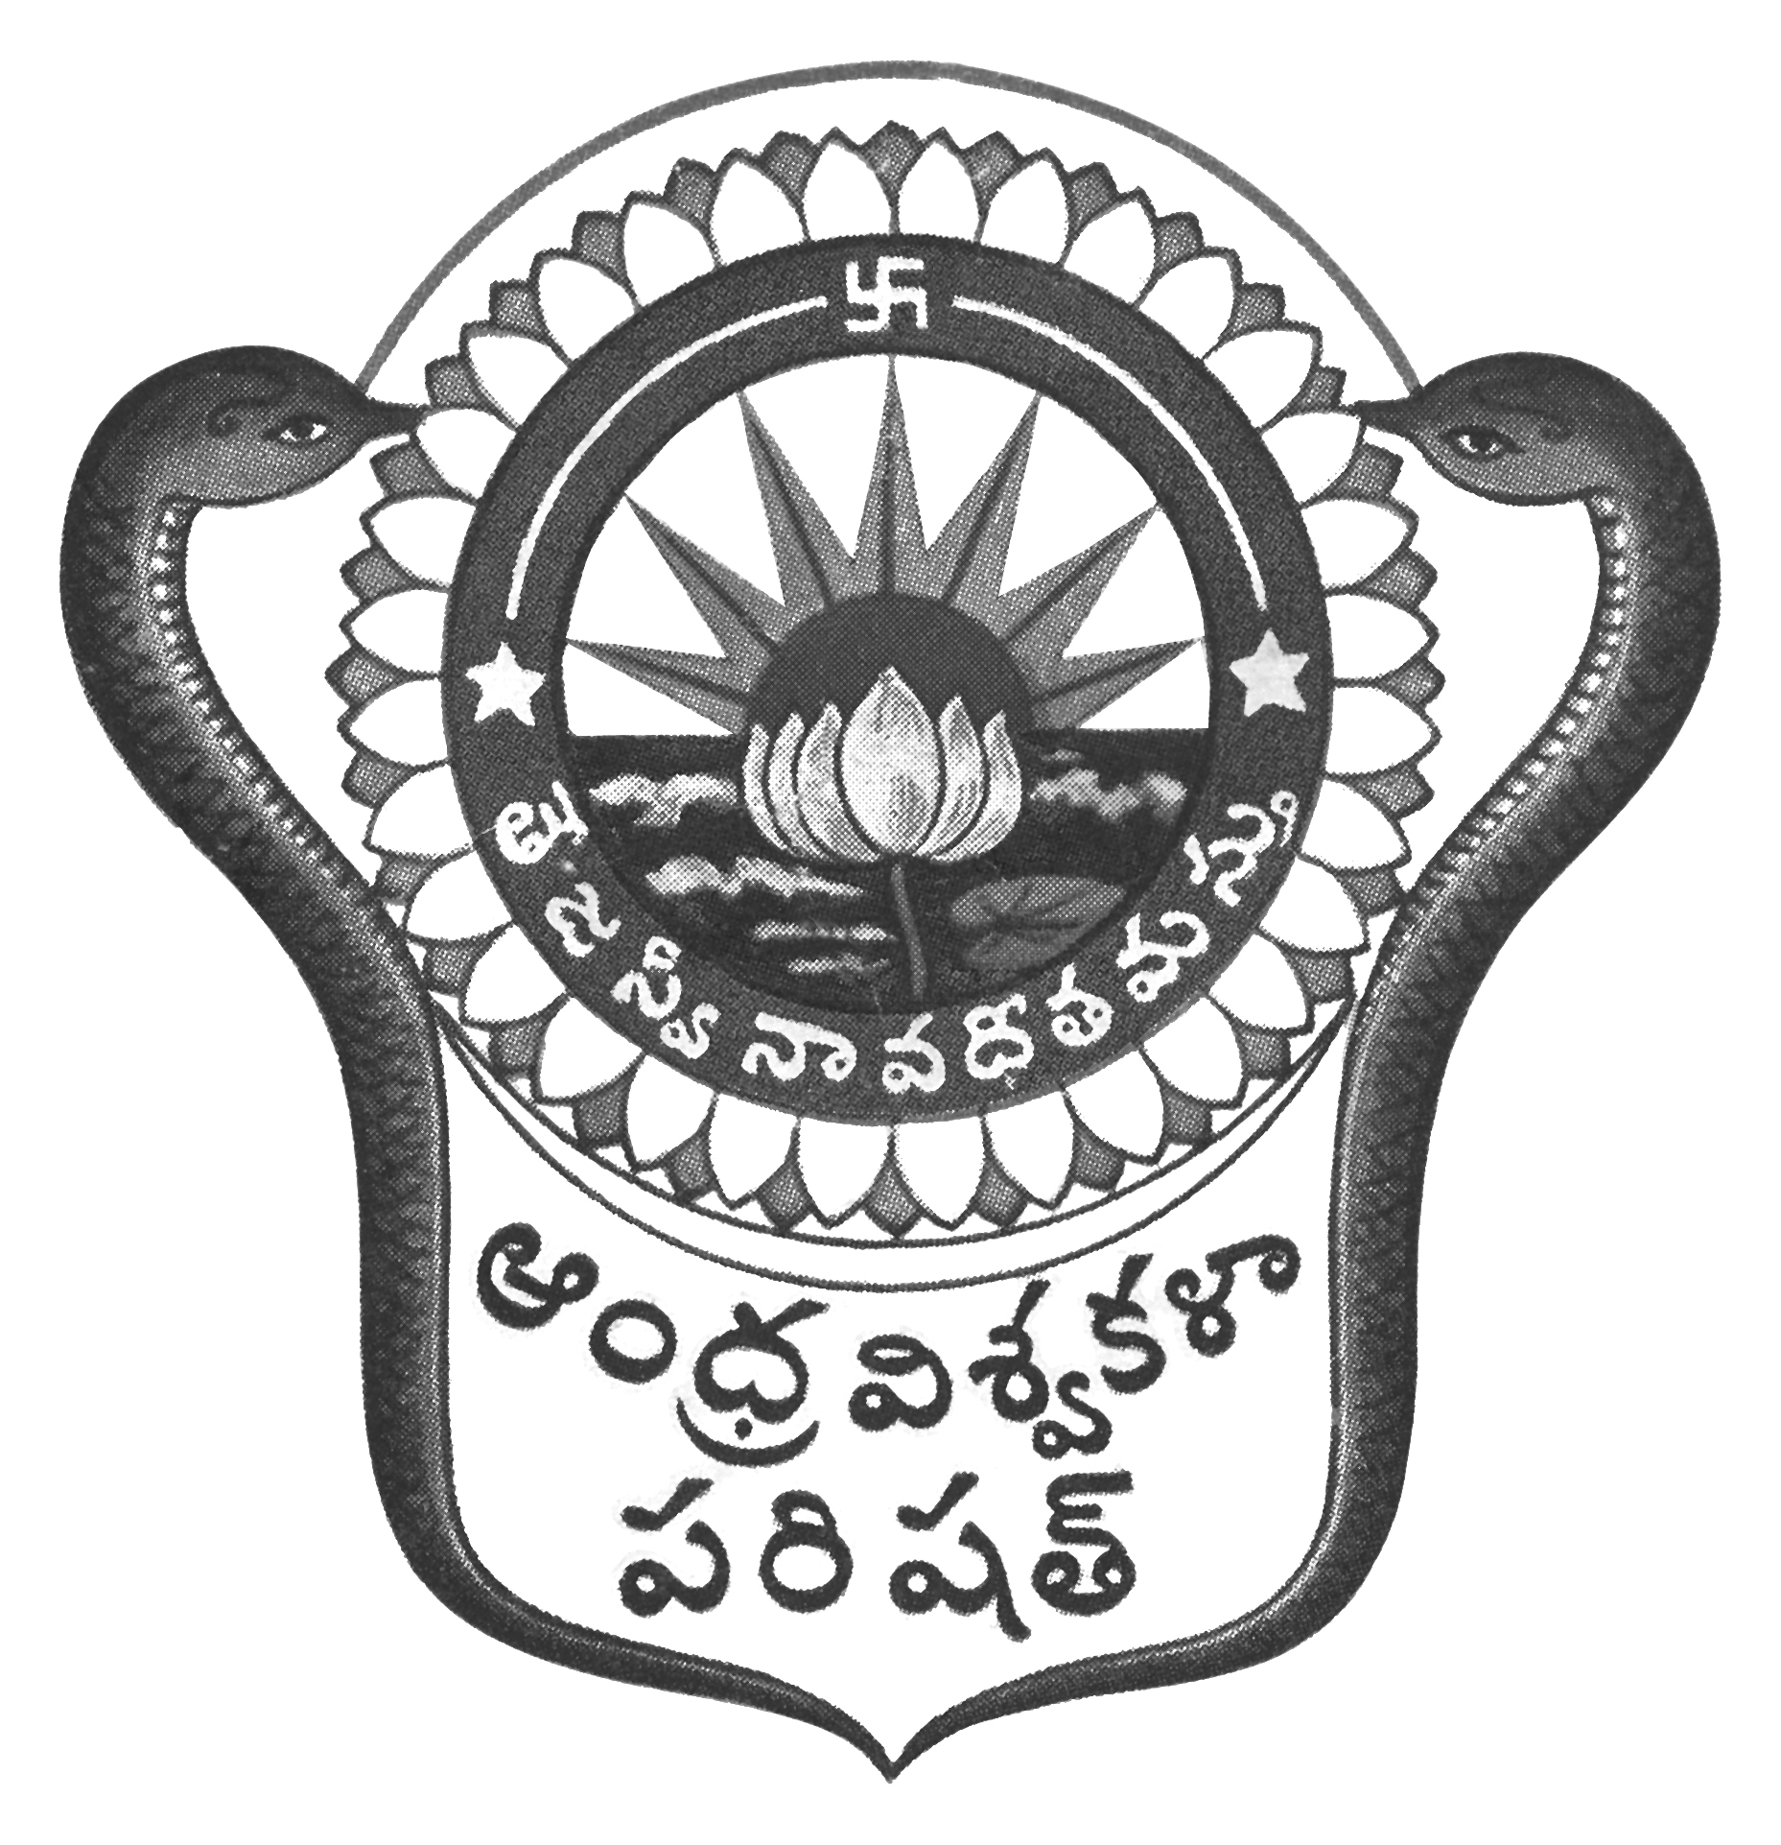
Prof.N.Vijay Mohan, M.P.Ed., DNIS., NIS., PG.DSM, Ph.D.  Director & Head  Dept. of Physical Education & Sports Sciences  Andhra University  Visakhapatnam-530 003 (AP) | 0891-2844496  Cell: 9703831117  vijaymohansports@gmail.com  ausportsvsp@gmail.com  Web: andhrauniversity.edu.in

No.AUSB/ICGS/Circular-2 (Revised)/2019-20 Date: 31-08-2019

To
The Principals,
Affiliated Colleges of Andhra University,

CIRCULAR-2 – REVISED

Sir/Madam,

Sub:- Andhra University Inter-Collegiate-cum-University team selections 2019-20 – Reg.
&&&
The Andhra University Inter-Collegiate-cum-University team selections to the following events will be conducted on the dates and venues noted against the events. The players should report at the venue with the necessary eligibility along with passport size photograph duly signed by the Principal (Facsimile not allowed) on the reverse side on the photograph and pinned to the eligibility Performa. Students born on or after 01-07-1994 are eligible. The players should report at 8.00 AM to the Organizing Secretary with eligibility.

S.No | EVENT | DATE | VENUE
01. | Kabaddi (Women)  Inter-Collegiate-cum-University selections | 11.09.2019 | Venue changed at Andhra University Campus, Visakhapatnam
02. | Kabaddi (Men)  Inter-Collegiate-cum-University selections | 12.09.2019  to  13.09.2019 | Postponed, dates will be announced later

Thanking you, Yours sincerely,
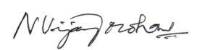
(N.VIJAY MOHAN)
DIRECTOR OF PHYSICAL EDUCATOIN
AND SECRETARY SPORTS BOARD

