ANDHRA UNIVERSITY
DEPARTMENT OF PHYSICAL EDUCATION AND SPORTS SCIENCES
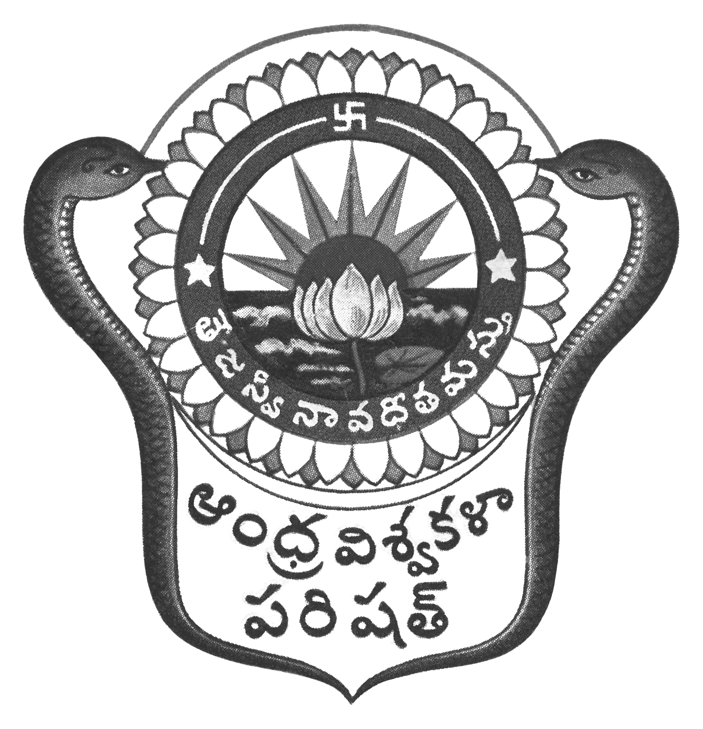
Prof.N.Vijay Mohan, M.P.Ed., DNIS., NIS., PG.DSM, Ph.D.  Director & Head  Dept. of Physical Education & Sports Sciences  Andhra University  Visakhapatnam-530 003 (AP) | 0891-2844496  Cell: 9703831117  vijaymohansports@gmail.com  ausportsvsp@gmail.com  Web: andhrauniversity.edu.in

Date: 17-08-2018

C I R C U L A R

Jnana Bheri Run

The Jnana Bheri Run, scheduled on 18th August, 2018 is postponed. The date will be informed later. Kindly note the change and inform the participants.
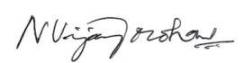
(N.VIJAY MOHAN)

Copy to the Dean, CDC, AU
Copy to the Dean, Students Affairs, AU

