ANDHRA UNIVERSITY
DEPARTMENT OF PHYSICAL EDUCATION AND SPORTS SCIENCES
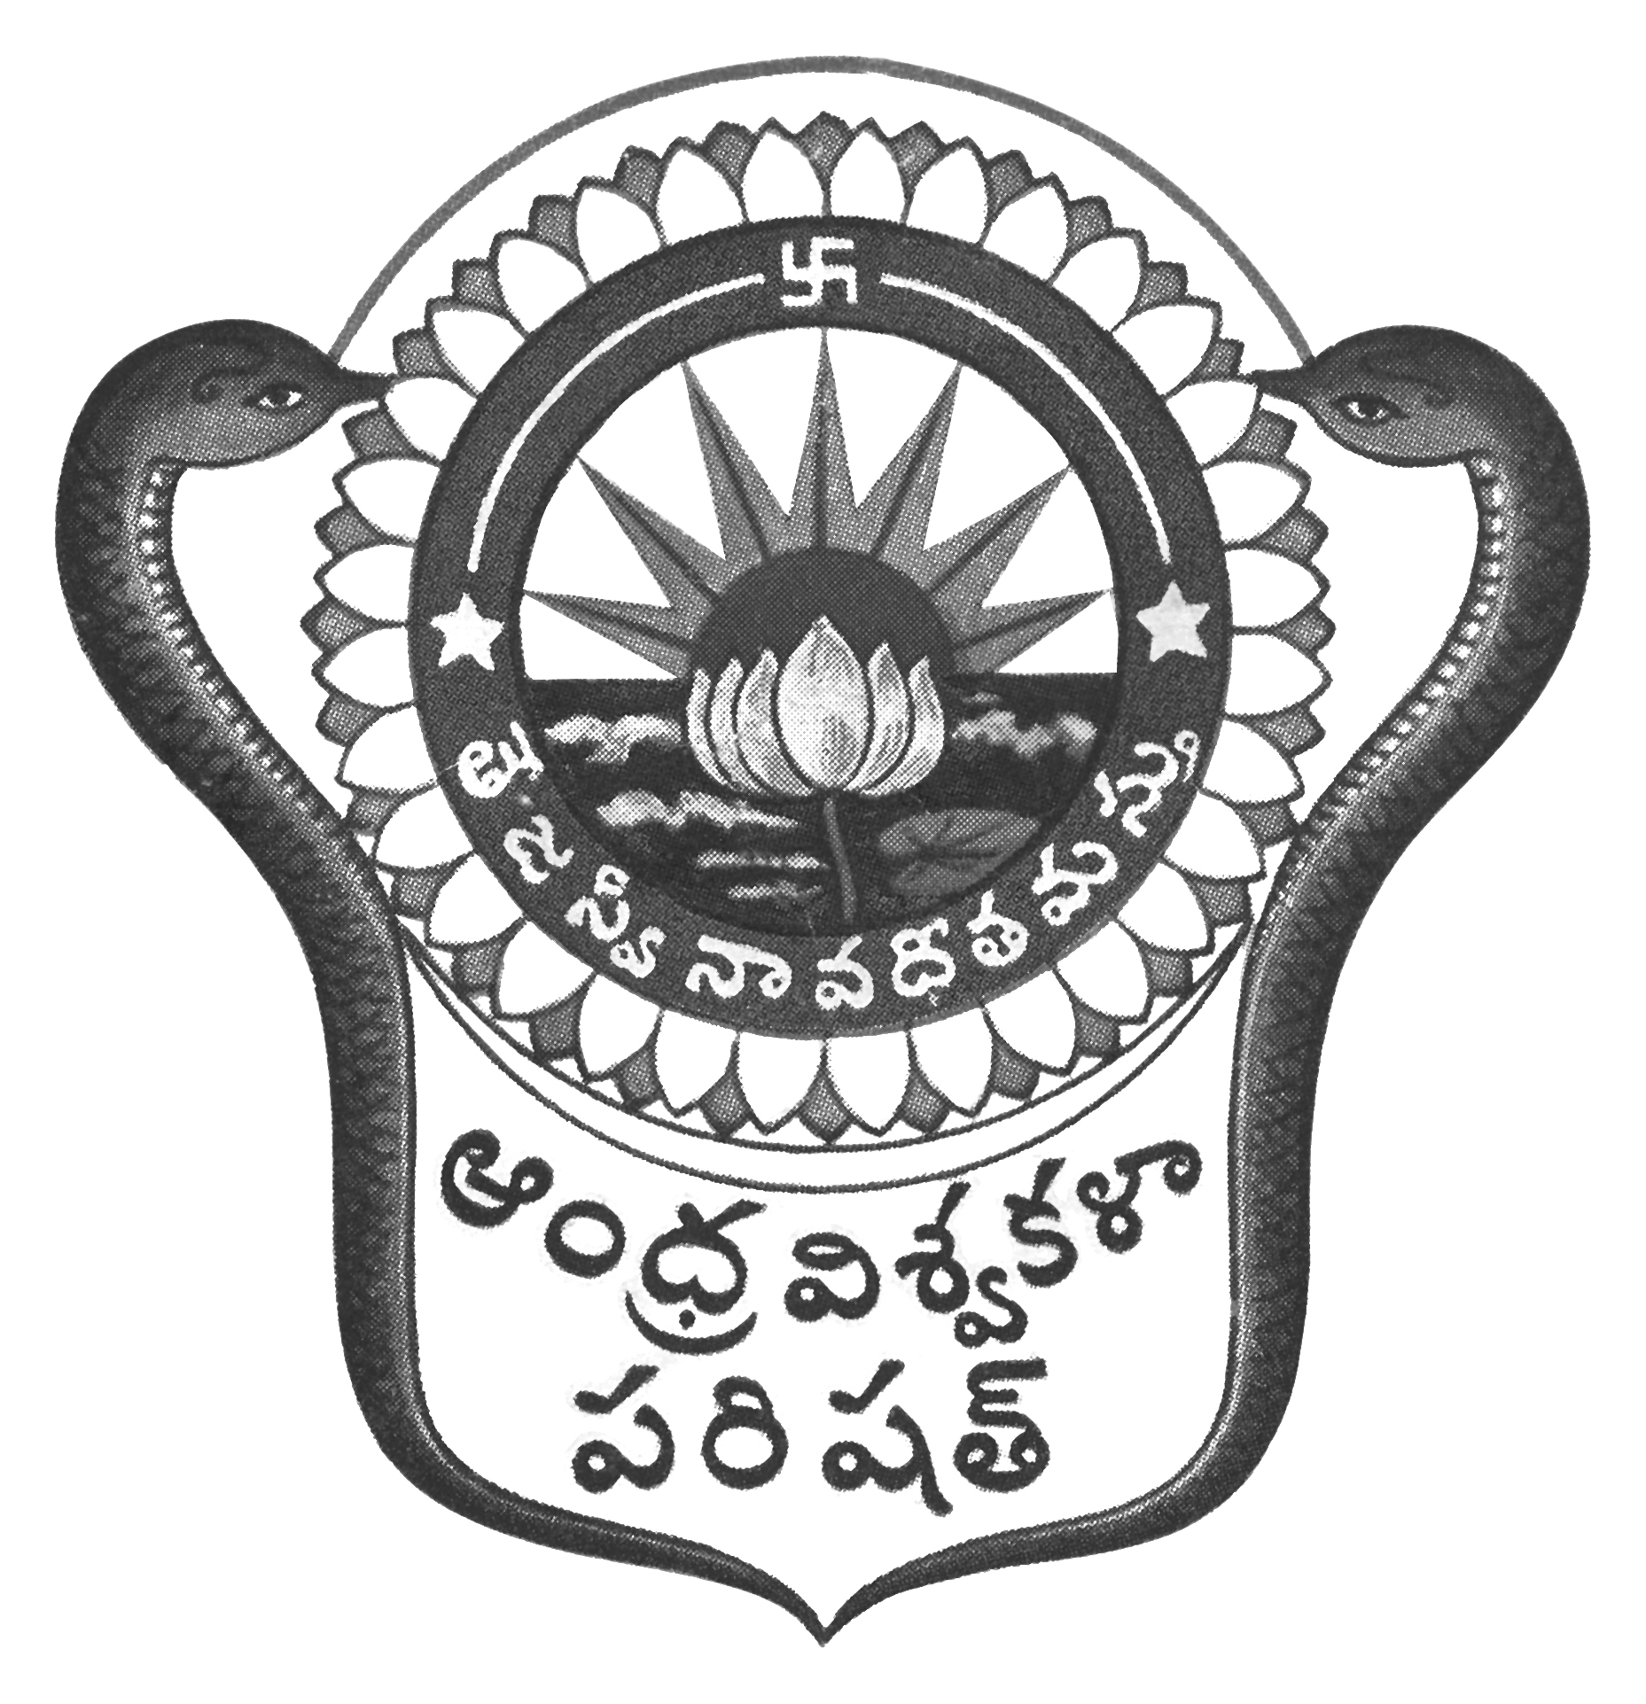
Prof.N.Vijay Mohan, M.P.Ed., DNIS., NIS., PG.DSM, Ph.D.  Director & Head  Dept. of Physical Education & Sports Sciences  Andhra University  Visakhapatnam-530 003 (AP) | 0891-2844496  Cell: 9703831117  vijaymohansports@gmail.com  ausportsvsp@gmail.com  Web: andhrauniversity.edu.in

Dt.03.07.2019
To
The Physical Directors/Lec. In Physical Education,
Andhra University Affiliated Colleges

Meeting notice

The Annual General meeting of the Physical Directors /Lec. in Physical Education affiliated to Andhra University will be held on 8th July 2019 at 11.00 a.m. at the Department of Physical Education and Sports Sciences to discuss matters related to Andhra University Sports activities for the year 2019-20 so as to forward/submit the same to the Andhra University Sports Board.

All the Physical Directors/Lec. in Physical Education are requested to make it convenient in attending the meeting.

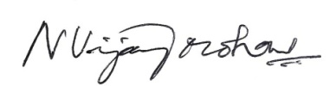
(N.VIJAY MOHAN)

